Contents
Executive Summary 2
Introduction 9
Healthy Women Healthy Babies Mini-Grant Initiative 12
A Community-Centered Funding Process 13
Cycles 1 and 2 of the HWHB Initiative: Six Mini-Grantees 16
Cycle 3 of the HWHB Initiative: Eight Mini-Grantees 16
Cycle 4 of the HWHB Initiative: Ten Mini-Grantees 16
Evaluation Overview 16
Evaluation Outcomes 17
Healthy Women, Health Babies Logic Model 19
Data Collection Methods, Processes, and Instruments 20
Reach and Impacts of the Overall Initiative 21
Reach and Impact of Specific Mini-Grantees 28
Black Mothers In Power 28
Breastfeeding Coalition of Delaware 31
Christina Cultural Arts Center 34
Delaware Adolescent Program Inc. 36
Delaware Coalition Against Domestic Violence 39
Delaware Multicultural and Civic Organization 44
Impact Life 51
Parent Information Center 53
Reach Riverside Development Corporation 56
Rose Hill Community Center 57
Guaranteed Basic Income Demonstration 62
Overview of the Program 62
Findings 62
Outcomes 63
Return on Investment Study 67
Conclusions and Next Steps 69
Appendix A: National Best Practices to Improve Birth Outcomes and Reduce Racial Disparities 70

Acknowledgements
This evaluation was funded by the Delaware Department of Health and Social Services, Division of Public Health. Health Management Associates would also like to acknowledge staff at the mini-grantee organizations and participants in the Healthy Women Health Babies Initiative who responded to surveys and participated in interviews and focus groups.

Executive Summary
Nationally, pregnancy-related mortality rates among Black and Native American women are more than three and two times higher, respectively, than among White women (41.4 and 26.2 vs. 13.7 per 100,000). The rates of preterm births, low birthweight births, or births for which women received late or no prenatal care are also higher among U.S. Black and Native American women compared to White women. In Delaware, the overall infant mortality rate has declined over the past two decades from 9.3 deaths per 1,000 live births in 2000-2004 to 6.5 deaths per 1,000 live births in 2016-2020 (Delaware Health Statistics Center, 2023). However, these data mask a significant racial disparity. The Black infant mortality rate of 11.6 is more than three times higher than the White rate of 3.8 deaths per 1,000 live births (Delaware Health Statistics Center, 2023).

In recent years, Delaware has undertaken a variety of efforts to reduce infant and maternal mortality and target racial disparities in outcomes. Two of these efforts are highlighted in this report:

- The provision of Healthy Women Healthy Babies mini-grants through Delaware Department of Health and Social Services, Division of Public Health (DPH) to 11 community-based organizations located within zones at highest risk of poor birth outcomes.
- The implementation of place-based initiatives to achieve collective impact on health, such as a Guaranteed Basic Income demonstration program that addresses the social determinants of health.
Healthy Women Healthy Babies Mini-Grant Initiative
More than eight years ago, in response to high infant mortality rates and racial disparities in these rates, the Delaware Healthy Mother Infant Consortium (DHMIC), in collaboration with DPH, implemented several initiatives. Their goals were to reduce the number of babies who die before their first birthday, address health disparities, and improve the health of women before, during, and in between pregnancies. The Healthy Women Healthy Babies (HWHB) program was designed to identify women in HWHB zones who were at the highest risk of poor birth outcomes and to address any underlying health conditions that predispose them for poor outcomes before they get pregnant or if they are already pregnant, and to work with them to mitigate their risk.

In 2019, an additional Initiative was implemented to address the social determinants of health, the major drivers behind the racial disparity. The aim of the HWHB Mini-Grant Initiative is to build state and local capacity, and test small scale innovative strategies in the community to shift the impact of social determinants of health tied to root causes related to infant mortality.

Since early 2020, 11 community-based organizations (CBOs) throughout Delaware have been funded and supported by this initiative to provide services, support, and community resources to women of color (and their partners and children). The CBOs want to help them live healthier, happier lives – with a long-term goal of reducing disparities in maternal and infant health outcomes.

While the specific services and activities provided by the CBOs vary greatly, each CBO’s work taps into a strategy or set of strategies that has been shown to be supportive of this long-term goal. The CBOs that were funded through the four funding cycles of the HWHB Initiative are:

- Black Mothers in Power
- Breastfeeding Coalition of Delaware
- Christina Cultural Arts Center
- Delaware Adolescent Program Inc.
- Delaware Coalition Against Domestic Violence
- Delaware Multicultural and Civic Organization
- Hispanic American Association of Delaware
- Impact Life
- Parent Information Center
- REACH Riverside (Kingswood)
- Rose Hill Community Center
Mini-grantees have collected data throughout their involvement with the Initiative, with support from HMA. These data, along with interview and focus group data collected by HMA, and data collected as part of the Guaranteed Basic Income Demonstration, serve as the basis of this report.

Reach and Impacts of the Overall Initiative
In the first 3.5 years of the initiative, mini-grantees provided services to 2,655 people, primarily to women of color. Services provided by organizations are designed to meet the needs of pregnant and parenting women, many of whom were experiencing challenges with physical and mental health in addition to food and/or housing insecurity, social isolation, lack of childcare, and having significant challenges accessing medical care. Services provided include:

- Breastfeeding education and support; referrals to other services
- Career and professional development training
- Case management and referrals to other services
- Doula training and certification; education to providers about doulas
- Education and social support to build healthy relationships and life skills
- Fitness classes, self-improvement classes, wellness classes
- Health access funds to help meet basic needs
- Nutrition counseling, meal planning and recipes
- Parenting education and support
- Pop-up cashless grocery stores
- Training to other providers.
Impacts
The data collected by mini-grantees demonstrate positive outcomes across 2,655 people served between January 2020 and June 2023. throughout the state. These findings are reinforced by qualitative data collected through interviews, focus groups, and surveys over the course of the initiative.

Table 1: Mini-Grantees, Areas of Impact and Details about Impacts, Delaware, 2019-2023
Mini-Grantee | Key Areas of Impact | Details about Impacts
Black Mothers in Power | Increase the number of Black doulas in Delaware | 20 new doulas trained
Breastfeeding Coalition of Delaware | Increase the rate and duration of breastfeeding | 79% of participants reported they were still breastfeeding at the end of seven months (national average is 43%)
Christina Cultural Arts Center | Increase skills in self-care and parenting, sense of support and community, knowledge of child’s development, confidence in parenting, parents’ well-being | 80%+ of parents report high levels of protective beliefs and behaviors
Delaware Adolescent Program Inc. | Increase healthy relationships among youth; empower youth to make decisions about the reproductive health and future | 75% of participants completed a life plan and 71% said they intend to use it; increases in beliefs of control over when they become pregnant, in using contraception or abstaining, and in setting goals and achieving them
Delaware Coalition Against Domestic Violence | Reduce financial stress and increase hopefulness of participants; provide counseling and referrals to needed health and economic supports; increase health care provider support; screening and referral of survivors for domestic violence services | 97% of participants reported feeling more hopeful, 82% of participants reported that receiving the flex funds reduced their financial stress
Delaware Multicultural and Civic Organization | Increase healthy life skills and improved economic status; improve professional skills and job readiness | 100% of participants applied for at least one job after using the career counselor, more than 2/3 discovered new career paths, developed new skills, became more committed to their education
Hispanic American Association of Delaware | Reduce participant stress, anxiety, and depression | Participants had statistically significant reductions in stress
Impact Life | Reduce food insecurity and improve access to healthy food options and nutritional education; improve physical health | To be reported at the end of Cycle 4
Parent Information Center | Increase the number of doulas, particularly women of color, in Delaware; increase awareness about doulas | 50 doulas trained and 40 women served by doulas, statistically significant gains in knowledge
REACH Riverside | Improve fatherhood engagement and skills; improve access to basic need items | Increased skills and knowledge about being a good father
Rose Hill Community Center | Increase participation in physical activities; knowledge, attitudes, intentions towards nutritional food options; physical and mental wellness; reduced stress | Reduced stress among participants

Guaranteed Basic Income Demonstration
In January 2021, as an expansion of the Healthy Women, Health Babies Mini-Grant Initiative, the State of Delaware began implementation of a Guaranteed Basic Income (GBI) Demonstration program for pregnant women. The GBI Demonstration was created with input and support from DHSS, the DHMIC and the SDOH Subcommittee of the DHMIC. Community partners include Rose Hill Community Center, the Delaware Coalition Against Domestic Violence, and Stand by Me, all of which provide services and support to the participants.
The GBI Demonstration provides $1,000 a month in the form of a debit card for two years to women who enroll during their first or second trimester of pregnancy. Women must have incomes less than the federal poverty line. A total of 40 women are enrolled in the Demonstration. Participants also receive linkages to and guidance on prenatal care and post-partum care, financial coaching, and referrals for primary health care, mental health, and personal health and wellness. GBI is part of Delaware’s Healthy Women, Healthy Babies (HWHB) Mini-Grant Initiative, which provides free services to pregnant women at risk of poor maternal and infant health outcomes.

The GBI Demonstration is designed to reduce stress, improve the physical and mental health of participants and their children, and improve maternal and infant birth outcomes. Additionally, the Demonstration is designed to reduce utilization of emergency departments and decrease hospitalizations, and to increase financial stability, housing stability, and employment stability.

To measure these outcomes, the study included multiple methods, including analyses of data on spending of the stipend, quarterly surveys with participants, two rounds of interviews with participants, and analyses of cost and savings data to assess Return on Investment.

Findings
Over the course of the Demonstration, participants spent their stipend on basic necessities: food, household items, transportation, rent, Internet and phone, clothing, utilities, insurance, childcare, and personal hygiene. Nearly one-third of the stipends (between 27% and 30%) were used for food.

Health and Stress
Participants’ physical and mental health improved throughout their participation in the Demonstration. For example, the number of self-reported days (out of the last 30) when their physical health was not good went down (from 1.4 days at pretest to 1.1 days in the third quarter), as did the number of days of poor mental health (from 5.6 days to 4.8 days). The number of days that poor health prevented participants from engaging in their daily activities also went down (from 4 to 3 days). Utilization of the emergency department and hospitalizations over the past 12 months also went down substantially. Levels of perceived stress also went down from pretest to the third quarter, from 3.07 to 2.79. While this change is not statistically significant (likely due to the low sample size), it is still a promising trend.

In interviews with GBI Demonstration participants, most women described a decrease in overall stress and an improvement in their physical and mental health. Participants could make ends meet and felt they were a better provider for all their children. Participants appreciated the close relationships they built with their case managers and were closer to meeting their personal and financial goals. Some women found new jobs, bought homes, paid off debts, and improved their credit scores.
Return on Investment
The were 10 direct and indirect benefits to the women and their babies, along with impacts to the local economy:

- Direct benefits of the GBI program start with the $1,000 a month in guaranteed income. This provides total yearly benefits of $480,000 to the 40 GBI participants. All the figures in this list are the value of other benefits and costs are for one year.

- GBI participants working full-time average $32,784 in annual earnings. Those working part-time average $16,758 in annual earnings. GBI helps workers search for work, prepare for work, and identify job opportunities. Participating in the GBI program led to an increase in aggregate earnings of $441,349 over one year.

- GBI participation also reduced food insecurity through direct support, as well as efforts ranging from making an in-house food pantry available and connecting participants to subsidized food programs such as the Supplemental Nutrition Assistance Program (SNAP) and the Women, Infants, and Children (WIC) program. The aggregate value of the SNAP benefits is $51,000 and the aggregate value of WIC benefits is $22,680.

- A critical problem facing all parts of the US., Delaware included, involves the lack of safe and affordable housing. GBI staff helped connect pregnant women and new mothers to safe and affordable housing. The aggregate value of these initiatives is $66,048.

- Earnings supplements are another important source of indirect benefits that help pregnant women and new mothers pay their bills and get on a path to self-sufficiency. An important earnings supplement is the Earned Income Tax Credit (EITC). The aggregate annual value of the EITC is $20,186.

- For GBI participants, the Temporary Assistance for Needy Families (TANF) program, which provides cash assistance, totaled $97,380 in aggregate benefits.

- Total benefits accruing to the mothers and their babies were $1,178,642.

- In addition to these total benefits to GBI participants, this study found important benefits related to reduced use of emergency department (ED) care and reduced inpatient hospital admissions. The ED savings are $21,600 and the inpatient savings are $229,520. The sum is $251,120. These savings will flow mainly to the Medicaid program, though they may also reflect benefits to participants in improved health, time saved, and hardship avoided through prevented visits and inpatient care.

- The total benefits to the State/federal government, via Medicaid savings, and the locality (in the form of the multiplier effect, explained below) equals $1,311,898.

- The grant total of benefits is $2,490,541 per year.
Ripple Effects – the “Multiplier”
In addition to the benefits that participants receive, there will also be favorable ripple effects as they begin to spend a large portion of their newly available guaranteed benefit income and their earnings, earnings supplements, and SNAP and TANF benefits. This ripple effect is called the “multiplier effect.” The multiplier effect is the overall change in spending as it flows into the economy.

Researchers at California State University Northridge (CSUN) developed a “community multiplier” by first estimating separate multipliers for each of the spending categories such as food, rent, utilities, etc.; and then weighting each industry multiplier by the percentage of service recipients’ income spent among these sectors of the local economy. This weighted average was calculated to be 1.9. For this reason, a multiplier of 1.9 was used. As it was calculated for poverty reduction efforts in low-income neighborhoods, it is more applicable to this research than a more general, theoretical multiplier.

Costs
The largest cost of the GBI program is $480,000 in debit card benefits. Other costs included costs to administer the program. The Delaware HWHB program leadership was very helpful in providing those detailed cost data. The project managers calculated salary levels, adjusted by the proportion of time for key staff members to operate and manage the GBI program. To this was added the value of employee benefits and overhead. The total staff cost was $107,947. Thus, the total annual cost of the program is $587,947.

Benefit-Cost Ratio and Return on Investment
The ratio of total benefits to total costs is 4.24 to 1. Thus, the grand total of benefits from the GBI program is more than four times the amount of the total costs of the GBI program. The Return on Investment (ROI) is 324%. This means that each dollar invested in the program yields over $3 in return.

Conclusions
The GBI program in Delaware is a smart investment with a very sizeable, positive return for participants, the state, and the local economy. This program, which combines monthly cash grants of $1,000 plus a cluster of important wrap-around services, improves the health of pregnant women, new mothers, and their babies. It also connects the women to important social and economic benefits including employment, food security, and safe and affordable housing. GBI also helps them achieve financial self-sufficiency and reduce stress and anxiety. The data suggest that the GBI program merits scaling up and replicating.

As the HWHB Initiative moves through its fourth year of implementation, evaluation data suggest the program, including the GBI Demonstration, is achieving its intended goals. Participants report reduced stress, improved physical and mental health, stronger connections with communities that support them, and improved relationships and quality of life. The ROI study of the GBI Demonstration shows that the investment in that part of the program pays for itself more than three times over. As the Initiative moves into its fifth and final year of implementation in 2024, work to support healthy women and healthy babies across Delaware will continue, and a final report will be developed and shared at that time.

Introduction
Nationally, pregnancy-related mortality rates among Black and Native American women are more than three and two times higher, respectively, than the rate for White women (41.4 and 26.2 vs. 13.7 per 100,000), as are rates of preterm births, low birthweight births, or births for which women received late or no prenatal care compared to White women. U.S. Black and Native American infants also have higher mortality rates than those born to White women. Both maternal death rates and racial disparities for Black women in the United States increased during the Coronavirus 2019 (COVID-19) pandemic, largely due to deaths caused by COVID-19. U.S. Black women had the highest maternal mortality rates during 2020 and 2021, and experienced the largest increase compared to 2019. The U.S. maternal mortality rate for Hispanic women has also increased, from less than the rate for White women prior to the pandemic to a similar rate in 2020 and 2021.

In Delaware, the overall infant mortality rate has declined over the past two decades from 9.3 deaths per 1,000 live births in 2000-2004 to 6.5 deaths per 1,000 live births in 2016-2020 (Delaware Health Statistics Center, 2023). However, these data mask a significant racial disparity. The Black infant mortality rate of 11.6 is three times higher than the White rate of 3.8 deaths per 1,000 live births (Delaware Health Statistics Center, 2023). Racial disparities in maternal mortality are also well documented (Division of Reproductive Health, National Center for Chronic Disease Prevention and Health Promotion, 2023). Between 2018 and 2022, the majority of the 11 maternal deaths in Delaware occurred among women of color (Delaware Maternal Mortality Review, 2022). Premature birth is by far the leading cause of infant mortality in Delaware. In 2020 and 2021, one in nine babies were born preterm in Delaware, which is 11.0% of live births.

In recent years, Delaware initiated a variety of efforts to reduce infant and maternal mortality and target racial disparities in outcomes, including:

- The Delaware MOMNIBUS in 2022, a package of legislation designed to reduce maternal and infant mortality and racial disparities, and expand maternal and infant health care access, was enacted:
- House Bill 234 - extends Medicaid coverage through the first year postpartum
- House Bill 340 - provides updates to the Child Death Review Commission and name change to Maternal and Child Death Review Commission
- House Bill 342 - includes protections for pregnant prisoners regarding restraints
- House Bill 343 - requires that Medicaid provide a coverage plan for doula services
- HS2 for House Bill 344 - requires bias and competency training for health care workers
- House Bill 345 - provides access to doula/midwifery services for women in custody of the Delaware Department of Correction.
- House Bill 80 - implements Medicaid coverage for doula care services for birthing people during pregnancy, labor, and delivery and postpartum by January 2024.
- The original health care provider-focused Healthy Women Healthy Baby Program (HWHB) has seven sites throughout the state that enroll high risk women into preconception, prenatal, and interconception care. HWHB-enrolled women were 10% less likely to smoke during pregnancy, were 9% less likely to deliver a low birthweight infant, and were 15% less likely to deliver a preterm infant as compared to Delaware women with similar risks factors but not enrolled in HWHB. In 2019, HWHB transitioned to a performance-based model largely based on the Healthy Start initiative model with all providers focused on reaching or exceeding benchmark performance indicators. Health care providers utilize evidence-based tools, protocols, and standardized messages and materials to improve services and support improved outcomes. (Women - Delaware Thrives (dethrives.com))
- The Delaware Birth Defects Registry monitors birth defects in Delaware and has shown no temporal increase in birth defects or higher rates compared to national averages.
- The Delaware Pregnancy Risk Assessment Monitoring System (PRAMS) has revealed high rates of preconception maternal risk factors for premature birth, including unplanned pregnancies and smoking. PRAMS allows targeted programming to improve health.
- The Delaware Child Death Review Commission explores root causes of infant and maternal deaths in Delaware.
- Development of a statewide education campaigns including the safe sleep campaign, “Long Live Dreams,” which helps reduce unsafe sleep deaths in the first year of life based on American Academy of Pediatrics recommendations; My Life My Plan life planning tools; and contraceptive access awareness.
- Delaware is recognized as the second leading state for early breastfeeding indicators.
- Development of Reproductive Life Plans helps Delawareans better plan their pregnancies and achieve optimal health before, during, and after pregnancy.
- Community Health Workers have been hired, trained, and deployed in HWHBs High Risk Zones.
- A DHMIC Doula Ad hoc Committee chaired by Delaware State Representative Melissa Minor-Brown and Christina Andrews, community-based Doula, to explore issues of integrating doulas into perinatal care during and after the COVID-19 pandemic. In collaboration with the Division of Medicaid and Medical Assistance, this committee is working toward implementing coverage of doula services through Medicaid.
- Delaware is in the process of enacting one-year postpartum Medicaid Coverage expansion.
- Delaware is implementing Medicaid coverage for evidence-based home visiting services focused on improving maternal and infant health. Currently, Delaware is a Maternal, Infant, and Early Childhood Home Visiting (MIECHV) Program federal grant recipient and supports a continuum of evidence-based home visiting programs including Nurse Family Partnership, Parents As Teachers, and Healthy Families America.

- Delaware has recognized Black Maternal Health Awareness Week since it started nationally in April 2019, and will do so again in 2023, inviting community members and health care professionals to participate in a variety of activities relating to Black maternal health, safety, and mortality.
- Delaware formally recognizes one individual and one organization annually for their in-state health equity work to improve health outcomes for mothers and babies.
- An annual infant mortality conference attracts over 350 attendees. Topics are focused on equity, racism, and social determinants of health. National and local speakers highlight accomplishments and innovative efforts.
- The state has partnered with key stakeholders in Delaware on educational and clinical programming. These stakeholders include Black Mothers in Power, Reach Riverside, faith-based communities, hospital systems, and Federally Qualified Health Centers (FQHCs).
- The state participates as a key stakeholder in the Delaware Contraceptive Access Now (CAN) Initiative, which led to a seven-percentage point increase in moderately effective methods of contraception and a 17% increase in women indicating their pregnancy was wanted “then or sooner”.
- The state established the Delaware Perinatal Quality Collaborative to improve and standardize hospital-based care including the provision of antenatal steroids, the care of neonatal opioid withdrawal syndrome, and the reduction of post-partum hemorrhage.
- Delaware developed the DEThrives.com website and social media platform (Facebook, Twitter, and Instagram) to further promote and educate consumers and professionals on DHMIC strategic priorities, as well as maternal and child health initiatives, best practices, data, and programming.
- A Guaranteed Basic Income demonstration program for pregnant women was implemented.
- Healthy Women Healthy Babies Mini-Frants were provided to 11 community-based organizations to address the social determinants of health to implement place-based initiatives to achieve collective impact on health.
It is this effort – the Healthy Women Healthy Babies Mini-Grant Initiative – that is the focus of this report, along with the Guaranteed Basic Income Demonstration, which grew out of the HWHB Initiative.

Healthy Women Healthy Babies Mini-Grant Initiative
More than eight years ago, in response to high infant mortality rates and racial disparities in these rates, the Delaware Healthy Mother Infant Consortium (DHMIC), in collaboration with the Division of Public Health (DPH), researched best practices across the nation. They implemented several initiatives to reduce the number of babies who die before their first birthday, to address health disparities, and to improve the health of women before, during, and in between pregnancies (see Appendix A).

DHMIC efforts were largely medical interventions, particularly through the Healthy Women Healthy Babies (HWHB) program. The strategy identifies women in HWHB zones who are at highest risk of poor birth outcomes. It also addresses any underlying health conditions that predispose them for poor outcomes before they get pregnant or if they are already pregnant, to mitigate their risk.

In the past few years, substantial funding has shifted to address the social determinants of health, the major drivers behind the racial disparity associated with poor birth outcomes. The aim of the HWHB Mini-Grant Initiative, as part of the infant mortality reduction work in Delaware, is to build state and local capacity and test small scale innovative strategies in the community to shift the impact of social determinants of health tied to root causes related to infant mortality. Primary strategies include: 1) social networking for empowerment; 2) father/partner involvement and engagement; 3) toxic stress/adverse childhood experiences; and 4) financial empowerment/self-sufficiency.

In 2019, DPH began to work with Health Management Associates (HMA) to implement and evaluate this collective impact initiative. HMA serves as the “backbone organization,” working closely with DPH to develop and administer a grant-making structure and to provide training and technical assistance to mini-grantees.

Since early 2020, this initiative has funded and supported 11 community-based organizations (CBOs) throughout Delaware to do what they do best: provide services, support, and community resources to women of color (and their partners and children) to help them live healthier, happier lives – with a long-term goal of reducing disparities in maternal and infant health outcomes. While the specific services and activities provided by the CBOs vary greatly, each CBO’s work taps into a strategy or set of strategies that has been shown to be supportive of this long-term goal.

The next section provides details about the reach and impacts of the overall initiative, followed by details about the specific work of each mini-grantee, including details about their reach and their achievements. Following this, findings from the Guaranteed Basic Income Demonstration, including findings from the Return on Investment study, are provided.

A Community-Centered Funding Process
The HWHB Initiative incorporates many nationally recognized best practices into one overarching initiative. It recognizes that CBOs working in the community often have the most intimate working knowledge of community needs and how to best meet those needs, and in ways that are truly center the culture and lived experience of their community members.
To that end, HMA, DHSS/DPH, and a community-based mini-grantee selection workgroup worked closely together to create a mini-grant application and process to screen, award, administer, and monitor mini-grants. The team built an equitable funding distribution model to allow for quick and efficient funding of community-based programming using processes that are minimally burdensome but also share key information necessary for making funding decisions.
Information gathered through an asset mapping process informed where and how mini-grants could be most effectively utilized to address social factors that influence infant mortality in the zones, with an equitable statewide distribution of funds. The team worked with stakeholders to develop an application and award process that strategically provided those demonstrating highest need with more resources. Grants were awarded only to organizations addressing one or more of the priority areas in their proposals and which had specific measurable objectives that clearly articulated that they planned to provide services in the HWHB zones.
Figure 1: HWHB Priority Areas
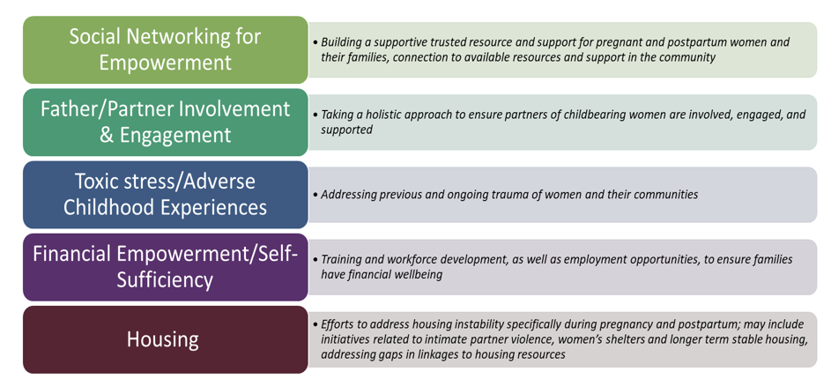

During the initial and subsequent mini-grant application cycles, HMA disseminated the mini-grant application and process through multiple webinars and other virtual communications in partnership with DPH and community partners. These efforts targeted existing CBOs that provide services in HWHB zones in the defined priority areas, as identified in the asset mapping process and through community listening sessions.
During the application process, mini-grant applicants were supported by disseminating promising practices proven to be effective in other locales related to the identified priority areas, as well as information on strategies that could be adapted related to data collection, evaluation, and continuous quality improvement. In addition, support was provided to applicants during the application-development process, including answering questions and providing guidance as needed.
Interested CBOs presented their proposed ideas to the community selection workgroup and HMA, which scored the presentations and requested full mini-grant applications from the top tier of respondents. The Advisory Committee reviewed the applications and selected mini-grantees for funding and support.

Figure 2: HWHB Awards, 2019-2024
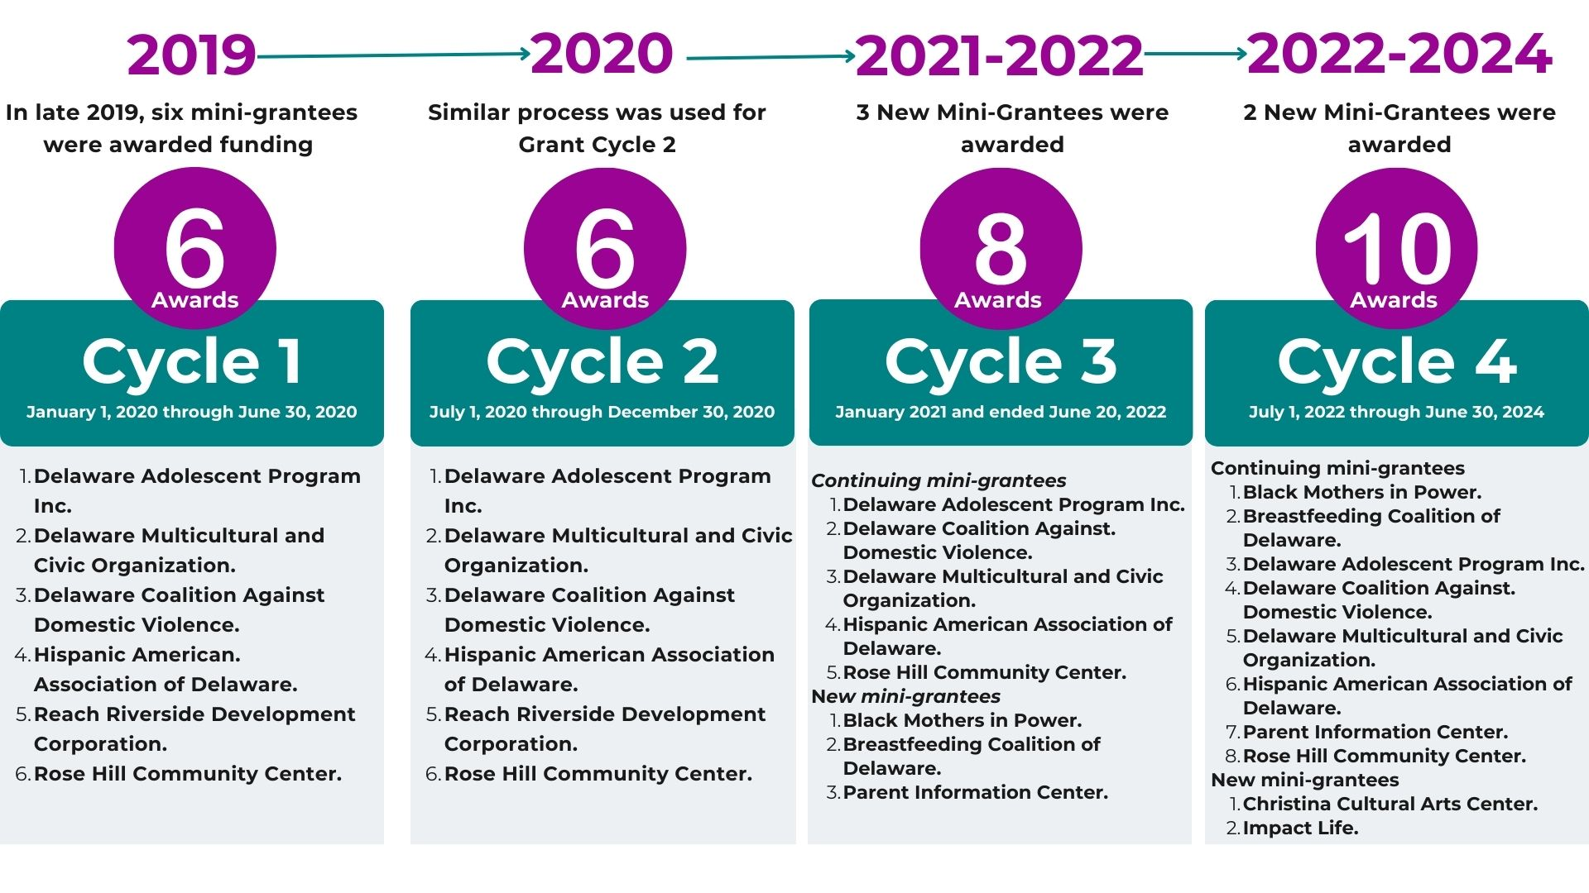

Cycles 1 and 2 of the HWHB Initiative: Six Mini-Grantees
Through this process, in late 2019, six mini-grantees were awarded funding and support for Grant Cycle 1 of the HWHB Initiative, which ran from January 1, 2020 through June 30, 2020. A similar process was used for Grant Cycle 2, which began on July 1, 2020 and continued through December 30, 2020.

In addition to the initial funding, capacity building grants were awarded to all six organizations during Cycle 2. These capacity building grants were designed to provide additional funding and support in targeted areas of need for mini-grantees and the women and girls they serve. Unfunded organizations were eligible for capacity building funding to support their efforts to be more competitive for funding in future cycles. One organization, Black Mothers in Power, applied for and received capacity building funding to develop a blueprint for their organization, a website, and to obtain 501c3 status so they could apply for future funding.

The six mini-grantees proposed to provide a variety of services and supports to women and girls, including social supports, educational opportunities, flex funds for critical needs, mental health and counseling supports, and nutrition and fitness opportunities. Some programs included support for partners.

Five of the six mini-grantees had very successful implementations and showed promising outcomes. One mini-grantee, Reach Riverside Development Corporation (Kingswood), struggled to implement their program due to staff turnover and ongoing staffing shortages, leading to their decision at the end of Cycle 2 not to reapply and instead focus on internal capacity building.

Cycle 3 of the HWHB Initiative: Eight Mini-Grantees
Using the same funding process, Cycle 3 of the HWHB Initiative began in January 2021 and ended June 20, 2022 and resulted in eight mini-grantees. In late 2020, five of the six Cycle 1 and 2 mini-grantees were awarded funding for Cycle 3, which was 18 months long. Three new mini-grantees were also funded for Cycle 3. The continuing mini-grantees proposed similar services to those they provided in Cycles 1 and 2, with a few exceptions. For example, Rose Hill Community Center in New Castle, Delaware added an additional program related to stress relief for women. Additionally, a few mini-grantees began to provide flex funds during the COVID-19 epidemic. The three new mini-grantees focused on training and certifying doulas (Black Mothers in Power and Parent Information Center) and on supporting new mothers (Breastfeeding Coalition of Delaware), including breastfeeding education.

Cycle 4 of the HWHB Initiative: Ten Mini-Grantees
Cycle 4 of the HWHB Initiative began on July 1, 2022 and will end on June 30, 2024. All eight Cycle 3 mini-grantees received continued Cycle 4 funding, and two new mini-grantees were funded as of November 15, 2022.

Evaluation Overview
As part of their application and as a condition of funding, each mini-grantee developed an evaluation plan (with support from HMA coaches and evaluation experts) designed to collect data that would be helpful to the mini-grantees for continuous quality improvement and to better understand the collective impact of all mini-grantees. Additionally, these evaluations can help the State with future resource allocation decisions.

Overall, each mini-grantee’s evaluation was designed to:
- Provide information to help mini-grantees learn what works and what does not, and make program improvements (local evaluation)
- Provide consistent information using some common measures to all mini-grantees to facilitate understanding of the collective impact of the initiative (cross site evaluation)
- Provide an opportunity for mini-grantees to build evaluation capacity by requiring them to examine their existing processes for data collection, tracking, and reporting and improve them so they are better positioned to collect and use data for this initiative and others.
Included in each grantees’ original evaluation plan is the purpose of their evaluation, their evaluation design, data collection processes, evaluation questions, and anticipated short-term (and sometimes medium-term) outcomes. Their plan also includes notations about what they are able to measure and answer within the funding cycle and within the short-term or medium-term.

These short-term and medium-term measures, outcome, and evaluation questions are then linked with the long-term outcomes of the overall initiative. In many cases, other research indicates that these short-term outcomes are linked with longer term outcomes of healthier pregnancy and birth outcomes. While these longer-term outcomes will not be measured as part of this evaluation, they are the intended longer-term outcomes toward which each program contributes.
Each grantee undertook a non-experimental evaluation that assesses process and outcome measures using a mixed-methods approach. Quantitative outcomes data were collected primarily using single-group pretest and posttest design. Qualitative data were collected via open-ended questions in surveys and/or via interviews or focus groups with participants. Process data were collected in the form of sign-in sheets (for classes and other activities) or via tracking of provision of case management services to measure service delivery. A core set of demographic data is being collected on all participants.

Evaluation Outcomes
While the grantees identified unique evaluation outcomes that were relevant to their programs, there were many common themes, including:

Mental Health
- Reduced stress, anxiety, and depression
- Improved quality of life and mental health
- Increased knowledge, attitudes, and intentions towards mental wellness
- Increased knowledge and attitudes about how to cope with stress
- Increased feelings of social support.
Physical Health
- Increased participation in physical activities
- Increased knowledge, attitudes, and intentions towards nutritional food options
- More positive birth experiences
- Increased breastfeeding.
Healthy Lifestyles
- Increased knowledge, attitudes, and intentions towards making healthy life choices
- Increased resilience to relationship pressure and intention to apply refusal skills
- Increased knowledge around breastfeeding and feelings of increased support
- Increased knowledge, attitudes, and intentions about sex, how to build healthy relationships, and pregnancy prevention strategies; pregnancy Increased knowledge about how to use and intentions to implement an individualized reproductive life plan.
Financial Stability
- Increased knowledge, attitudes, and intentions towards improving economic mobility
- Increased knowledge about technical and professional skills among students
- Increased job readiness among students.
Father Involvement
- Increased knowledge about strategies to create a supportive learning environment among students’ male partners
- Increased awareness of a father’s role in a healthy pregnancy and in a child’s healthy development
- Increased feelings of empowerment to be more integrated in the social and emotional support of the mother and child(children).
Social Networking
- Increased awareness of needed services and how to access them
- Increase health care providers’ (especially maternal and child health providers) perceived understanding of the dynamics of domestic violence from a health perspective; how to promote health relationships through universal education; and how to connect individuals experiencing domestic violence to community resources
- Increase referrals to community health workers from health care providers, especially those serving pregnant and parenting women of color
- Improve care/service delivery and availability of resources for victims and survivors of domestic violence, particularly women of color who are pregnant and newly parenting.
Longer Term Outcomes
- Long-term improvements in mental health and physical health
- Long-term improvements in quality of life, financial stability, and strong social networks
- Healthier pregnancies
- Improved birth outcomes.

Figure 3: Healthy Women, Health Babies Logic Model

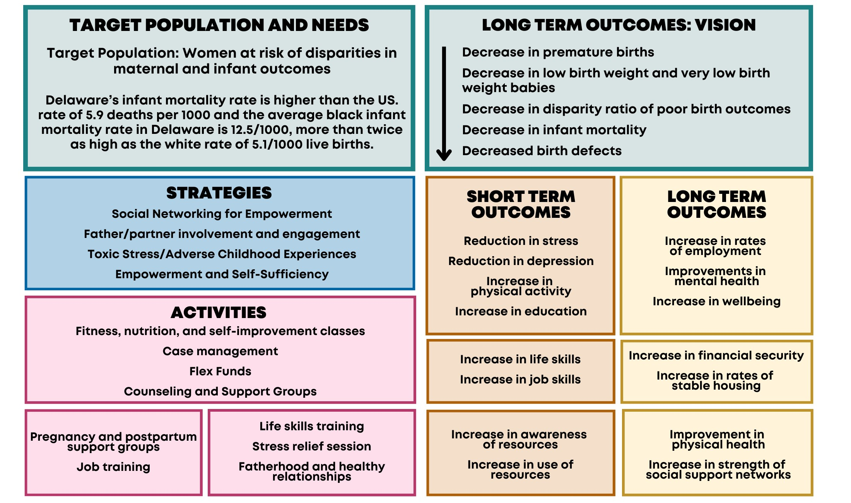

Data Collection Methods, Processes, and Instruments
Data collection methods and processes varied by organization, but some data elements were common across grantees. These common data elements include demographic data and a social determinants of health screening tool called Health Leads. All grantees were required to collect these cross-site measures (to the degree possible) to allow for an examination of similar data across all funded initiatives.

Demographic and Participation Data
Each grantee collects demographic data upon intake or initiation of services. All grantees collect a common set of demographic data at intake or initiation of participation in services. These demographic data elements are part of the cross-site measurement that allows for an examination of similar data across all funded activities. Specifically, grantees are required to collect the following for each participant: ZIP Code, age, race, ethnicity, gender, primary language, education level, employment, marital status, referral source (to the program), doctor or usual source of health care, pregnancy history (including current status), and desire to become pregnant in the next year. All grantees collect data on participation in services. While each grantee’s data collection process is unique to its services and activities, all grantees collect data on dates of service and types of services provided by participant.

Grantee-Specific Outcome Data
In addition to the demographic data, participation data, and the social determinants of health screening data, grantees collect data that are specific to their program, their goals, and their evaluation plan. Each grantee has its own set of pre/post or post-only instruments (i.e., surveys) to measure changes in the outcomes of interest. Most grantees collect data at the beginning of services and at the end of services or at the end of grant periods to assess changes in the outcomes of interest. A few grantees collect outcome data only at the end of services (post-only). The table below provides more information about grantee data collection instruments.

Table 2: Mini-Grantee Data Collection Instruments, 2020-2023
Grantee | Instruments
Black Mothers in Power | Pre/post surveys of doulas developed by Black Mothers in Power with HMA coaches on knowledge about doula services, satisfaction with the training program, and intentions to use their training; tracking of number of doulas trained
Breastfeeding Coalition of Delaware | Regular surveys of participants about breastfeeding support
Christina Cultural Arts Center | Parent Assessment of Protective Factors (modified)
Delaware Adolescent Program Inc. | Pre/post survey designed by Delaware Adolescent Program Inc. with HMA coaches measuring changes in attitudes, knowledge, and behaviors related to mental health, goal setting, decision-making, and pregnancy prevention, as well as questions about program satisfaction
Delaware Coalition Against Domestic Violence | Services/Referrals Tracking Spreadsheet; Health Access Fund Requests Tracker; a retrospective, two-question post survey to measure the impact on financial stress and hopefulness among flex fund recipients
Delaware Multicultural and Civic Organization | A single post-program survey containing survey items from several benchmark instruments used to measure changes in technical and professional skill knowledge

Table 2: Mini-Grantee Data Collection Instruments, 2020-2023 (continued)
Grantee | Instruments
Hispanic American Association of Delaware | Depression, Anxiety, and Stress Scale (DASS) pretest in the first meeting of the support group and DASS posttest and at the end of each client’s participation in the support groups
Impact Life | Tracking of all services provided and utilization of services
Parent Information Center | Surveys of knowledge gained and satisfaction with training; tracking of number of doulas trained
REACH Riverside | Every Man Counts post-survey
Rose Hill Community Center | Perceived Stress Scale pretest and posttest; weekly weight survey (self-reported weight); additional survey of health behaviors

Reach and Impacts of the Overall Initiative

Reach
In the first 3.5 years of the initiative, mini-grantees provided services to 2,655 Delawareans. Just under 97% of participants were women. About 50% were Black, 24% White, and 7% multi-racial. Over half of participants who provided information about their ethnicity were Hispanic. The average age of participants was 29.

Between 30% and 40% of participants were experiencing (or had recently experienced) food and housing insecurity, social isolation, lack of childcare, or significant challenges accessing medical care. The average participant reported experiencing three of the eight concerns measured in the assessment: food, utilities, stable housing, childcare, cost of health care, transportation to health care, health literacy, and companionship.

Almost half of participants reported that, in the last 12 months, they sometimes ate less food than they needed because there was not enough money for food. Over 40% were worried they would not have stable housing in the next two months, and over 40% said they had faced potential loss of utilities in the last 12 months. Almost one-third said they could not see a doctor or get health care because of cost or lack of transportation, and almost 40% struggle with health literacy. Almost 40% said they lack companionship and have challenges with childcare.

Table 3: Needs of HWHB Mini-Grantee Initiative Participants at Intake, Delaware, 2020-2023
Area of Need | Question | Number | Percent
Food | In the last 12 months, did you ever eat less than you felt you should because there wasn't enough money for food? | 479 | 47%
Utilities | In the last 12 months, has the electric, gas, oil, or water company threatened to shut off your services in your home? | 422 | 41%
Stable Housing | Are you worried that in the next 2 months, you may not have stable housing? | 441 | 43%
Child Care | Do problems getting child care make it difficult for you to work or study? | 384 | 37%
Cost of Health Care | In the last 12 months, have you needed to see a doctor, but could not because of cost? | 326 | 32%
Transportation to Health Care | In the last 12 months, have you ever had to go without health care because you didn't have a way to get there? | 318 | 31%
Health Literacy | Do you ever need help reading hospital materials? | 405 | 39%
Companionship | Do you often feel that you lack companionship? | 386 | 38%
Urgent Needs | Are any of your needs urgent? For example: I don't have food tonight, I don't have a place to sleep tonight? | 179 | 17%
Want Assistance | If you checked "yes" to any boxes above, would you like to receive assistance with any of these needs? | 322 | 31%
*Source: Health Leads Social Needs Screening Tool data collected by mini-grantees, Delaware, 2020-2023

Services provided by organizations are designed to meet the needs of pregnant and parenting women, many of whom were not only experiencing challenges with physical and mental health but were often experiencing food and/or housing insecurity, social isolation, lack of childcare or significant challenges accessing medical care.

Table 4: Mini-Grantee Primary Areas and Number of People Served, Delaware, 2020-2023
Mini-Grantee | Primary Area | Number Served
Black Mothers in Power | Doula training and certification, education to providers | 20
Breastfeeding Coalition of Delaware | Breastfeeding education and support, referrals to other services | 396
Christina Cultural Arts Center | Parenting education and support | 32
Delaware Adolescent Program Inc. | Education and social support to build healthy relationships and life skills | 335
Delaware Coalition Against Domestic Violence | Health access funds, referrals to other services, training to providers | 427
Delaware Multicultural and Civic Organization | Career and professional development training, parenting/fatherhood education and support | 291
Hispanic American Association of Delaware | Parenting support, social support, counseling, education, referrals to other services | 350
Impact Life | Pop-up cashless grocery “stores”, consultations with nutritionist, meal planning and recipes, case management and referrals | 576
Parent Information Center | Doula training and certification program, educational webinars for doulas, doula candidates, and the general public | 122
REACH Riverside | Fatherhood/partner engagement, flex funds to mothers | 26
Rose Hill Community Center | Fitness classes, nutrition classes, self-improvement classes, workshops, yoga, massage | 80
Total |  | 2,655
*Source: Mini-grantee administrative data

Impacts
From the beginning of Cycle 1 through the middle of Cycle 4), the services provided by mini-grantees resulted in:
- 70 new trained doulas who are women of color
- Significant reductions in stress, and reductions in social isolation, increases in social support and improved mental health
- Improved physical health
- Increases in breastfeeding
- Increases in parenting skills, life skills, and job skills
- Increased knowledge of and access to other needed services.
In many instances, changes that were measured quantitively were statistically significant.

Table 5: Mini-Grantee Key Areas of Impact, Delaware, 2020-2023
Mini-Grantee | Key Areas of Impact | Details about Impacts
Black Mothers in Power | Increase the number of Black doulas in Delaware | 20 new doulas trained
Breastfeeding Coalition of Delaware | Increase the rate and duration of breastfeeding | 79% of participants reported they were still breastfeeding at the end of seven months (national average is 43%)
Christina Cultural Arts Center | Increase skills in self-care and parenting, sense of support and community, knowledge of child’s development, confidence in parenting skills, focus on parent’s wellbeing | 80%+ of parents report high levels of protective beliefs and behaviors
Delaware Adolescent Program Inc. | Increase healthy relationships among youth, empower youth to make decisions about the reproductive health and future | 75% of participants completed a life plan and 71% intend to use it; increases in beliefs of control over when they become pregnant, in using contraception or abstaining, in setting and achieving goals
Delaware Coalition Against Domestic Violence | Reduce financial stress, increase hopefulness of participants, provide counseling and referrals to help with access to health and economic supports, increase health care provider support, screening and referral of survivors for domestic violence | 97% of participants reported feeling more hopeful, 82% of participants reported that receiving the flex funds reduced their financial stress
Delaware Multicultural and Civic Organization | Increase healthy life skills and improved economic status, improve professional skills and job readiness | 100% of participants applied for at least one job after using the career counselor, 2/3 discovered new career paths, developed new skills, and became more committed to their continued education
Hispanic American Association of Delaware | Reduce participant stress, anxiety, and depression | Participants had statistically significant reductions in stress
Impact Life | Reduce food insecurity, improve access to healthy food options and nutritional education, and improve physical health | In process
Parent Information Center | Increase the number of doulas, particularly women of color, increase awareness about doulas | 50 doulas trained, 40 women served by doulas, with high rates of satisfaction, statistically significant gains in knowledge.
REACH Riverside | Improve fatherhood engagement, improve access to basic need items | Increased skills and knowledge about being a good father
Rose Hill Community Center | Increase participation in physical activities; knowledge, attitudes, and intentions towards nutritional food, physical/mental wellness, reduce stress | Reduced stress among participants
*Source: Mini-grantee administrative and survey data

The data collected by mini-grantees demonstrates positive outcomes across the 2,655 people served across the state during the first 3.5 years of the Initiative.

Additionally, qualitative data collected through interviews, focus groups and open-ended questions in surveys over the course of the initiative reinforces these findings.

Impacts Identified in Key Informant Interviews
During Spring 2023, HMA conducted a series of key informant interviews with mini-grantee staff and participants. The purpose of these interviews was to learn more about the experience of participants and organizations with the HWHB initiative during its first years. Four HWHB program participants and 13 CBO staff were interviewed from nine of the mini-grantee organizations.

Program Impacts
Meeting Tangible Needs
Mini-grantees provide a variety of supports to address social determinants of health, such as flex funds, referrals to housing and employment, counseling, food, and other tangible supports. Participants and staff noted the importance of these supports in helping improve physical and mental health and improve quality of life for participants. During the COVID-19 pandemic, these needs were amplified and met when mini-grantees adapted by reorganizing their services to accommodate COVID-19 safety measures, and by creating virtual services. Because they collect data about social determinants of health related needs at intake, organizations were able to provide referrals, food bank access, shelter access, case management, and other resources.

Improving Physical and Mental Health
While participants receive tangible resources to address social determinants of health, the programs impact them in social and emotional ways. Staff noted that their survey data captured increases in healthy days for both physical and mental health for participants. Participants reported improved health and wellness for themselves and for their families. Participants also reported increased self-confidence and self-esteem, being able to advocate for themselves, decreased stress and anxiety, and increased hope for the future.

Building Healthy Habits, Learning, and Reducing Isolation
Across programs, a common theme was the sense of community and support these programs provide the participants, often described as a safe space or “safe haven.” Participants noted that a big benefit of being involved with the initiative was “finding a community.” One participant described their program as “A breath of fresh air” and the staff support, “like a big hug,” speaking about the experience of being a first-time mother, including associated stress. Participants repeatedly affirmed wanting to find a sense of community, whether with in an exercise class with other mothers or cooking fajitas for the first time in a recovery home.

Participants spoke about being able to build healthy habits around nutrition and meal prepping, building a “never give up” attitude through an exercise program, learning to take care of themselves to have a healthy baby, and being able to find purpose in helping their community. Across the programs, participants are building healthy habits around physical health, mental health, self-confidence and esteem, spirituality, social interaction, and community support. Doulas, community health workers, and support groups provide participants with pregnancy information and support, including but not limited to, new mothers. Participants noted that they often go to the program for a specific reason and come away with much more. All interviewees said they would recommend the program to a friend – and have done so, as they wanted to share it with their communities.

Building Capacity within Community Based Organizations
Being part of the HWHB Initiative meant consistent and ongoing funding for mini-grantees to do long term planning, program development, and capacity building. Program representatives shared how necessary and critical the funding is to their programs’ success. Many grantees believed that one of the biggest benefits was to establish connections with other mini-grantees, as it was helpful to collaborate and align initiatives. Organizations can network, keep one another on track and accountable, and share ideas about serving similar populations. Grantees shared that the quarterly HWHB Learning Collaboratives were useful to enhance these connections.

Grantees also reported that the support around program management, data collection, reporting and budgeting were useful. One grantee stated that the initiative filled some gaps for an organization that was not fully ready to meet extensive funder requirements, allowing them to build capacity. That said, some mini-grantees found the data collection, evaluation, and financial reporting process and requirements to be very time consuming and a heavy lift. Grantees also reported having challenges providing all the resources participants may need, including transportation and materials in a second language.

The Future of Healthy Women Healthy Babies
All grantees agreed that more initiatives like this should exist in more places, and more funders should use this model. Specifically, grantees felt this application process was more accessible to small organizations and was culturally sensitive. Grantees expressed that more state and federal dollars should go to existing programs and small organizations as ongoing and consistent funding. Across grantees, there was a consensus that the need is greater than people understand, their staff are overwhelmed, and they do not have the people or resources to meet the needs. One grantee spoke about the ongoing major public health crisis when it comes to Black maternal health, nothing that there is still not enough attention, funding, and access to health care. Participants echoed this, expressing that some of their peers have outstanding needs and could use more support. Similarly, grantees spoke about the importance of sustainability for the progress and capacity they have built in the last three years.
“We have harnessed this powerhouse and don’t know where it is going from here, we need to leverage these programs as we get to the end of these grants, we need to think about sustainability, we need to figure out what is next.”
HWHB Mini-Grantee
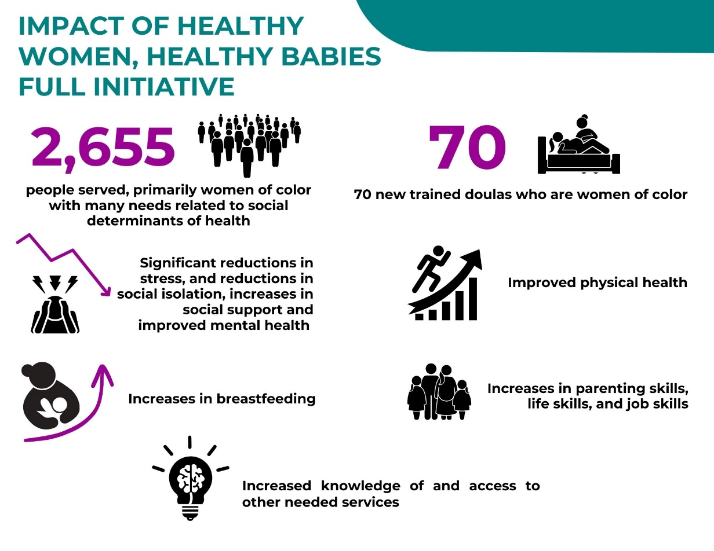
Figure 4: Reach and Impact of the HWHB Initiative, Delaware, 2020-2023

*Source: Mini-grantee administrative and survey data, Delaware, 2020-2023

Reach and Impact of Specific Mini-Grantees

Black Mothers In Power

With its HWHB funding, Black Mothers in Power (BMIP) is training Black women to become doulas across Delaware. BMIP is working to increase the number of trained and certified Black women who are doulas, to incorporate doula services into the local health system, and to link with other local programs that work with young women.

Black Mothers in Power
Key Activities:
- Training Black women to become doulas in Delaware.
- Raising awareness around the importance of doula services.
Intended Outcomes:
- Increase the number of Black doulas in Delaware.
The training program includes doula training, a mandatory book club, creating a doula directory, post-partum trainings, doula mentorship, and a social media awareness campaign.
“This is not just a Black people issue, healthcare in America, specifically maternal care for all women and birthing people in America, we are not faring well and that really tells you where a society is going. We are asking for everyone to stand with us or stand behind us in this issue.”
Shané Darby, MA, Founder, Black Mother in Power

During Cycle 2, BMIP worked with a small capacity building grant to build out the organization. Cycle 3 was BMIP’s first funding cycle where 10 women were enrolled in the training program. Currently, in Cycle 4 10 women are also enrolled in the training program.

Reach
Across its two cycles of funding (Cycles 3 and 4), BMIP trained 20 new doulas. All trainees were African American/Black women in their early 20s to early 50s who live in ZIP Codes 19720, 19702, 19802, 19804, and 19805. In addition to the initial training weekend, ongoing training activities included workshops, book club meetings and reports (held monthly), submission of a birth plan and postpartum plan, and submission of a local resource list.

After the training sessions during both cycles, a training satisfaction survey was administered to trainees. Across cycles, trainees rated their satisfaction with the overall training weekend and the trainer as “Very Satisfied.” Across both cycles, participants had the opportunity to give open-ended feedback. Participants expressed that they were grateful for the opportunity and that the trainer was skilled at conveying information. They felt prepared to help clients, and reported that the training was helpful and empowering.

Impact
“I feel prepared and ready! I already have a client for the Postpartum assignment. I’m just grateful for our trainer and this initiative to have this opportunity. I’m so excited! Overall, it was a weekend we’ll spend learning a multitude of skills! Thank you ALL!”
“I truly loved our time together learning about important (black) maternal health matters. I am looking forward to implementing what I have learned, and to having the support of amazing women, who are compelled with purpose to serve.”
Black Mothers in Power had three goals:
- to increase the number of trained Black Doulas in Delaware by 10 women per cycle
- to incorporate doula services into at least two larger health systems, such as hospitals, correction facilities, birthing centers, and other health care facilities
- to link doula services to at least 15 other CBOs that serve pregnant women and girls.

BMIP met their first goal with 10 women completing the three-day training both years. Six doulas went on to complete the BMIP certification program during Cycle 3, and four more doulas completed the certification training during Cycle 4. Other goals are still being pursued in Cycle 4.
“I think our trainer was amazing. She incorporated stories that helped connect the information being taught to practical ways to work with families. I think it was beneficial to hear her methods in getting started with working with families. She had a good flow with teaching and allowed us to ask as many questions as we needed.”
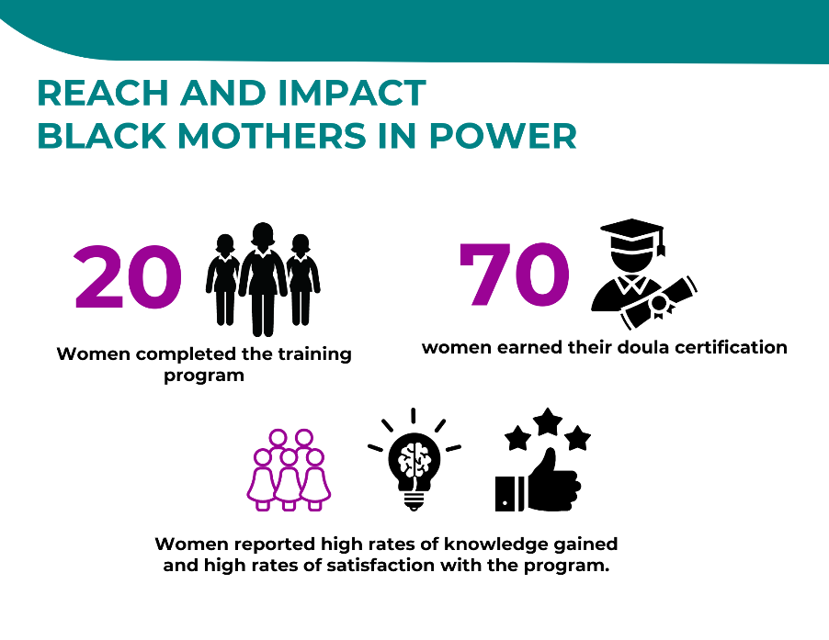
Figure 5: Reach and Impact of Black Mothers in Power, Delaware, 2021-2023
*Source: Black Mothers in Power administrative and survey data, Delaware, 2021-2023

“My experience and a lot of women’s experience is it is traumatic, birthing people who are faced with that, now they have those resources available to them. They can google something, and it is going to pop up. It is not going to be like me when I put in Black Doula Delaware, nothing. There is something for people to have access to.”

Shané Darby, MA, Founder, Black Mother in Power

Breastfeeding Coalition of Delaware

The Breastfeeding Coalition of Delaware (BCD) provides an incentive based breastfeeding program that brings together families who may be at high risk for breastfeeding barriers. Black mothers, mothers from low-income families, mothers experiencing housing instability, and non-English speaking mothers are at high risk at not commencing and continuing breastfeeding. These high-risk mothers are offered text support, monthly breastfeeding education, and support groups.

The program consists of two seven-month cohorts, each including a monthly one-hour breastfeeding education group. Cohorts begin with a one-month needs assessment period for all registered mothers. During this period, BCD conducts screening to identify needs that can impact birth outcomes and makes referrals. BCD provides needed supplies and addresses participants’ needs. BCD added this needs assessment phase in response to early implementation experience that indicated urgent challenges need to be addressed before the program can focus on supporting participants’ breastfeeding intentions.

A total of 12 virtual breastfeeding education groups have taken place across the two cohorts, with additional one-on-one outreach and support, as well as in-person and virtual special events such as baby showers. Participants can request a free in-person or virtual consultation if they need additional breastfeeding support. They can also request any breastfeeding/parenting supplies they need at any time. To encourage program participation (attendance at monthly education groups and completion of follow-up surveys), monthly incentives including diapers, wipes, and breastfeeding supplies are available. Supplies such as a baby carrier and stroller are available to those who attend at least four group meetings.

At the end of each cohort, BCD hosts a group baby shower celebration with the participants who attended 75% or more of the breastfeeding education groups and completed the follow-up surveys. The shower also provides an opportunity to refer participants to other services or supports.

Breastfeeding Coalition of Delaware
Key Activities:
- Breastfeeding education and support
- Screening and referrals for health and social needs.
Intended Outcomes:
- Increased rate and duration of breastfeeding
- Identification of health and social needs and completed referrals to address them.
Reach
In Cycle 3, 140 women participated in activities with BCD. As of June 2023, 256 women had participated in Cycle 4, and BCD is finding that demand for these services continues to grow.

“Before this initiative, I’ve always felt a tad bit of frustration because we’ve seen that there was need for low-income people, communities with high infant mortality. We’ve touched and helped over 300 moms at this point, not only helping with breastfeeding but broader needs for safety like car seats, diapers, wipes, and other supplies they need to be good parents. The number of people we’ve been able to help has been mind-blowing.”

Shamiya Gould, IBCLC, Program Leader
Figure 6: Reach and Impact of the Breastfeeding Coalition of Delaware, Delaware, 2021-2023
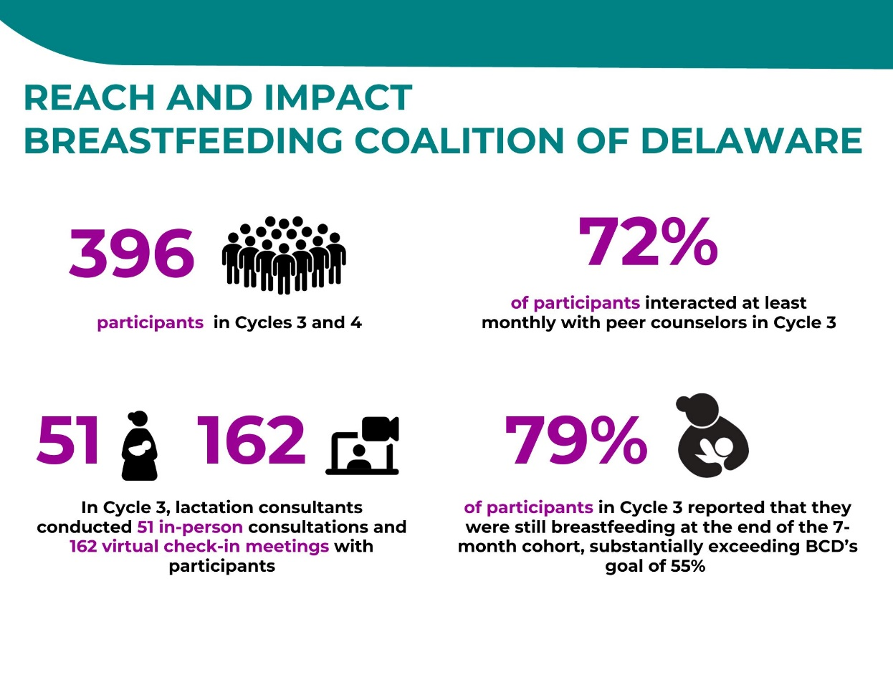
*Source: Breastfeeding Coalition of Delaware administrative and survey data, Delaware, 2021-2023

Outcome Data
Intended outcomes of the program include:
- Increased breastfeeding duration
- Identification of most important breastfeeding barriers among new mothers
- Identification of the most important supplies used to overcome breastfeeding barriers
- Increased satisfaction with the breastfeeding program
- Increased awareness of the level of staff engagement required to improve breastfeeding behaviors.

Beginning with Cohort 2, participants completed periodic surveys after breastfeeding education sessions. These surveys ask mothers about their current feeding methods, breastfeeding exclusivity and duration, any breastfeeding difficulties, overall experience with breastfeeding, what they learned in the program and any impacts of participating in the program. BCD has dramatically exceeded its ambitious targets for breastfeeding rates.. Adding the initial screening to identify needs beyond breastfeeding support and making resource connections before delving into breastfeeding-related topics has proven to be very meaningful to participants. It enables program counselors and leadership to start to address stressors and frustrations that go beyond breastfeeding barriers and impacts health more broadly.
“[We] used to jump right into the program...But this time around really wanted to address what they needed before they started. What barriers do we need to address prior to starting breastfeeding groups; where do they need referrals to; food bank, 211 for shelter needs; mini-case management where we really see what the needs are and address them, then get into the meat of the breastfeeding content.”

Shamiya Gould, IBCLC, Program Leader

Christina Cultural Arts Center

The Early Childhood Education Arts Academy (ECEAA) at Christina Cultural Arts Center (CCAC) is a full-day preschool program that features an arts-enriched educational experience for children 3-5 years of age to successfully prepare them to enter Kindergarten. The program includes a strong parent involvement component with a critical emphasis on expression through the arts. The Parent Academy is a two-generation approach supporting parents/adult caregivers of the children enrolled in the ECEAA and the Early Head Start programs in Wilmington. The Parent Academy offers self-care workshops/activities which focus on the health and wellness of the parent/adult caregivers in a child’s life. The HWHB Initiative helps support the Academy and enhanced targeting of services to fathers.

Christina Cultural Arts Center
Key Activities:
- Parent Policy Council
- Fatherhood Meetings
- Self-Care Weeks
- Co-Parent Workshops.
Intended Outcomes:
- Increased skills in self-care and parenting
- Increased sense of support and community
- Improved knowledge of child’s development
- Increased confidence in parenting skills
- Increased focus on parent’s well-being.
As part of its HWHB funding, CCAC hosts a variety of activities and services, including monthly Parent Policy Council meetings to garner parent input on programming and to enhance leadership skills among parents, and Fatherhood Meetings focused on critical conversations with and for fathers. Self-Care Weeks are offered twice annually to fathers; ideas and actions are inspired, instigated, and fueled by the Parent Policy Council. Parent/Co-Parent workshops offer workshops on communication skills, health and well-being of children, child development, parenting, and other topics essential to a family’s well-being.
Reach
In the first six months, 32 community members engaged with CCAC’s services. Basic demographic data was collected on these participants. All participants (100%) described their race as Black/African American and ethnicity as non-Hispanic. The majority (72%) were female and 28% were male.
Community members participated in an average of two activities between December 2022 and June 2023. The most popular activities were a multicultural presentation in March with 19 attendees; an End-of-Year Move Up and Graduation event in June with 19 attendees; and a Spring Fling Formal Dance, also in June with 17 attendees.
Impact
CCAC began capturing the impact of its activities using an adapted version of the Parents Assessment of Protective Factors survey, which measures parents’ knowledge about and perceptions of their ability to engage in parenting. The survey focuses on protective factors and includes statements such as:
- I feel positive about being a parent/caregiver.
- I take good care of my child even when I have personal problems.
- I manage the daily responsibilities of being a parent/caregiver.
- I have someone who will help me get through tough times.
- I help my child calm down when he or she is upset.
Respondents are asked whether the statements seem “not at all like me or what I believe” or “very much like me or what I believe,” or somewhere in between. Between 80-100% of those surveyed chose “This is very much like me or what I believe” in response to every survey question, indicating a high level of protective factors.
This survey was administered in June of 2023 to 26 participants.

In future data collection efforts, CCAC will explore the degree to which participation with CCAC increased these protective factors.

Figure 7: Reach and Impact of Christina Cultural Arts Center, Delaware, 2022-2023
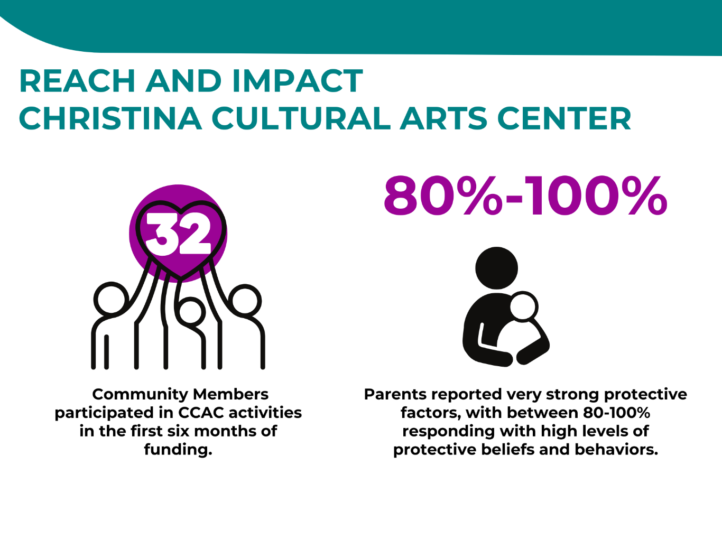
*Source: Christina Cultural Arts Center administrative and survey data, Delaware, 2021-2023

Delaware Adolescent Program Inc.

The Delaware Adolescent Program Inc. (DAPI) serves teen mothers and their partners in high-risk zones across Delaware. DAPI provides mentoring, support for social and emotional well-being, and support navigating the health and social services system. DAPI connects clients to maternal and child health care services, housing programs, financial management and economic empowerment programs, and stress reduction and maternal health courses and co-parenting workshops. The target population for this program and its evaluation is young women ages 12-19 who live in the identified HWHB high risk zones in New Castle, Kent, and Sussex counties.

Delaware Adolescent Program Inc.
Key Activities:
- Building healthy relationships education with youth
- Life skills development, life planning, and mentoring with youth.
Intended Outcomes:
- Increased healthy relationships among youth
- Empower youth to make decisions about the reproductive health and future.

Through the HWHB program funding, DAPI implements the evidence-based Love Notes curriculum. Nurses and Student Service Coordinator (SSCs) are trained on how to implement Love Notes to teach participants how to build healthy relationships. In addition to implementing Love Notes, other activities include nurses and SSCs helping participants draft individual life plans, matching participants to mentors, and providing educational sessions on specific life skills development.

DAPI’s goals are to:
- Increase resilience to relationship pressure and intention to apply refusal skills
- Increase knowledge about reproductive life plans and increases in intentions to use one
- Increase knowledge and attitudes about how to cope with stress
- Increase knowledge, attitudes, and intentions about how to build healthy relationships
- Teach strategies to prevent pregnancy and increase knowledge and healthy attitudes about sex.
DAPI’s evaluation focuses on measuring the effectiveness of the program in helping young women make healthy life choices and preventing teen pregnancy.

Reach
DAPI collects participation data on all services provided, as well as demographic data on the participants, including ZIP Code. To date, DAPI has provided services to 335 young women and girls in the first 3.5 years of the initiative.

Table 6: DAPI Participants,
Delaware, 2020-2023
Participants per Cycle
Cycle 1 | 69
Cycle 2 | 63
Cycle 3 | 109
Cycle 4 | 94
Source: DAPI Administrative data, Delaware, 2020-2023

While the young women and girls ranged in age from 13 to 22, three quarters of the participants were between the ages of 15 and 18. Half of participants (50%) were Black women and girls and 24% were White women and girls, 10% were multi-racial/bi-racial, and .3% were American Indian/Alaskan Native. Twenty-one percent were Hispanic. Over half of participants (57%) have been pregnant before and 33% were pregnant during the time they participated with DAPI. DAPI provided activities and events related to financial empowerment, nutrition and exercise, career and college readiness, toxic stress, father and partner involvement, and empowerment and self-esteem. In Cycles 3 and 4, completing a Life Plan was added to the curriculum.

Impact
To understand the impact of their program, DAPI uses a pre/post survey that asks participants a variety of questions about their relationships with trusted adults, their belief in their own abilities to plan for the future and make healthy decisions, and about their mental health. The survey also assesses knowledge about, attitudes toward, and intended behaviors around pregnancy prevention.

Across all grant cycles, data showed that the program was having the desired impact on participants’ knowledge and beliefs related to their reproductive health and decisions, as well as participants’ mental health, coping skills, and connections with trusted adults. For example, participants’ pre- and post-surveys showed improvement in their knowledge and confidence. There were statistically significant changes in knowledge, attitudes, and intended behaviors on many measures. For example, participants showed a statistically significant increase from pre to post in their beliefs that it is important to have a plan about how sex fits into their life. At post, participants were also statistically significantly more likely to say they know how to set a goal and achieve, keep themselves calm in stressful situations, and achieve goals even in the face of obstacles.

Table 7: Attitudes, Knowledge, Intended Behaviors of DAPI Participants, Delaware, 2020-2023
Item | Pre Mean | Post Mean | P-value (paired sample t-test) | N
It is important to always use condoms to protect against disease and help prevent pregnancy. | 1.37 | 1.25 | p=0.17 | 112
It is important to have a plan about how sex will fit into my life. | 1.99 | 1.68 | p=0.00* | 97
It is important to always use or make sure my partner uses other forms of contraception to protect against unplanned pregnancy. | 1.66 | 1.48 | p=0.09 | 109
I would feel comfortable saying no to my partner when I don't feel like having sex. | 1.48 | 1.69 | p=0.11 | 112
When I'm in a stressful situation, I feel like I have a trusted adult who I can ask for help. | 2.11 | 1.94 | p=0.17 | 109
In a crisis or chaotic situation at school, I know how to calm myself and focus on taking useful actions. | 2.23 | 1.85 | p=0.00* | 110
I feel like I am in control of when I become pregnant. | 2.48 | 2.13 | p=0.06* | 111
I know how to set a goal and take the steps to achieve it. | 1.96 | 1.54 | p=0.00* | 110
I believe I can achieve my goals, even if there are obstacles. | 1.88 | 1.43 | p=0.00* | 109
I have at least one close and secure relationship with an adult I trust (this includes parents, teachers, mentors, etc.) | 1.93 | 1.38 | p=0.00* | 109
*Significant at .05; Source: DAPI survey data, Delaware, 2021-2023

Additionally, a key measure of the DAPI program’s success is for participants to complete and intend to use a Life Plan Nurses and SSCs help participants draft individual life plans. To date, 75% of participants have completed a Life Plan, and 71% of them said they would use this plan in the next three months.

Figure 8: Reach and Impact of the Delaware Adolescent Program Inc.,
Delaware, 2020-2023
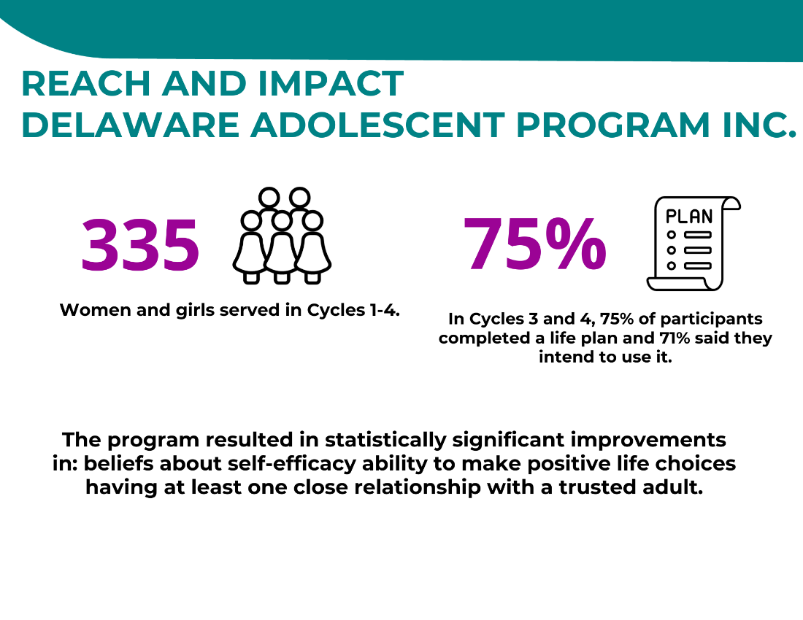
*Source: DAPI administrative and survey data, Delaware, 2021-2023

Delaware Coalition Against Domestic Violence

The work of the Delaware Coalition Against Domestic Violence (DCADV) under the HWHB Initiative expands the integration of its services with health services in New Castle County through its Community Health Worker Collaborative Project. The project integrates domestic violence and health services to improve the health and safety of victims and survivors.

Delaware Coalition Against Domestic Violence
Key Activities:
- Flexible Funds to survivors of domestic violence to address immediate needs and reduce stress
- Links to care coordination and system navigation services
- Counseling and supportive services
- Education and empowerment services
- Train health care providers to screen and refer for domestic violence.
Intended Outcomes:
- Reduce financial stress and increase hopefulness of participants
- Provide robust counseling and referrals to help participants access needed health and economic supports
- Increase health care provider support, screening and referral of survivors for domestic violence. services
Specifically, this initiative allows DCADV to expand service delivery to the HWHB target population, administer flexible Health Access Funds to support the safety and health of the participants, and train health care providers on best practices for domestic violence assessment and response. They work with direct service providers in the maternal and child health care and victim services fields to learn challenges and explore possible solutions.

DCADV’s goals for their HWHB funding and participation are:
- To increase health care providers’ (especially maternal and child health providers) understanding of the dynamics of domestic violence from a health perspective
- Promote healthy relationships through universal education
- Connect individuals experiencing domestic violence to community resources.
In addition, DCADV has expanded the program to serve women downstate and is participating in the Guaranteed Basic Income pilot.

Because of COVID-19, there were some changes to DCADV’s program. First, provider trainings could not occur as planned, so fewer trainings were held during the first two years of the pandemic (2021 and 2022). Second, the flex funds component became even more important as the economic impacts of the pandemic were felt by participants. Therefore, the evaluation evolved to become more focused on the use and impact of the flex fund component, while continuing to explore best practices and barriers to creating a referral pathway between health care providers and community domestic violence providers.

To answer their evaluation questions, DCADV collects data on services provided, data on the dissemination of flex funds, data on participants’ perceptions of the value and impact of these flex funds, and data on trainings provided to providers.

Reach
From the beginning of the initiative (January 2020) to June 2023, DCADV served 266 unique women. All women were pregnant, parenting a child under the age of five, and/or of reproductive age (ages 18-44 years old); and living in Wilmington, Claymont, Newark, and New Castle. DCADV is expanding to serve downstate regions, but the timeframe of this analysis does not yet include the downstate expansion. In addition, DCADV provided 125 trainings to health care providers so they can better identify and support survivors of domestic and sexual violence over the course of the program.

Participants received services including linkages to health care providers and social services, education and empowerment services, and counseling services.

Table 8: DCADV Participant Use of Health Access Funds, Delaware, 2020-2023
Cycle | New Participants Served | Previous Cycle Participants Served
Cycle 1 | 69
Cycle 2 | 48 | 43
Cycle 3 | 92 | 42
Cycle 4 through June 2023 | 57 | 76
Totals | 266 | 161

*Source: DCADV administrative data, Delaware, 2021-2023

Another key use of the HWHB grant funding throughout the program is the dissemination of health access or “flex funds.” During the first 3.5 years, HWHB health access funds were provided to 146 women. Funds were most commonly used to meet basic needs such as food, diapers, winter coats, and feminine hygiene products and for specific needs of participants’ children. Other common uses of the flex funds were to pay utility bills, meet physical needs and buy essential furnishings. Rent became an increasingly common use of flex funds as the cycles continued, reflecting rising housing costs and affordability challenges.
“The impact is really tied to long term relationships [built] with the community health advocates; decrease in isolation and increase in social support is the foundation of other impacts, including improvements in quality of life and reported reductions in poor health days.

We can see poor physical health and mental health days decrease over time as they remain engaged. Other impacts include reduction in financial stress and increased hope for the future; I think those are closely tied to flex fund availability through the program.”

Erin Ridout, MSW, MPH, Domestic Violence & Community Health

Table 9: DCADV Participant Use of Health Access Funds, Delaware, 2020-2023
What were the Health Access Funds used for? | Number of Times Funds Were Distributed
Basic needs (e.g., food, diapers, feminine hygiene products) | 283
Children's needs | 114
Essential furnishings | 66
Physical needs | 30
Utility Bills | 63
Transportation | 68
Employment assistance | 37
Rent | 47
Other (family activities, mental health needs) | 16
Move-in costs | 7
Education | 4
Legal assistance | 11
Security | 3
*Source: DCADV administrative data, Delaware, 2021-2023

Impact
As one measure of the impact of the flex funds, participants are asked to respond to a short two-question post survey, asking if the funds reduced their financial stress, and whether they were more hopeful after receiving the flex funds.

In Cycle 3, 83% of participants said the flex funds reduced their financial stress “completely” or “a lot,” and 97% said the flex funds made them feel more hopeful. (For comparison purposes, in Cycles 1 and 2, almost 96% of responding participants said the flex funds “completely” or “significantly” reduced their financial stress. Almost 96% of respondents said the receipt of the flex funds made them feel more hopeful.)

Table 10: Impact of Health Access Funds on DCADV Participant
Financial Stress, Delaware, 2020-2023
Did the funds reduce your financial stress? | Count and Percent
Completely | 22 (20%)
Significantly or “A Lot” | 72 (67%)
Somewhat | 12 (11%)
A little | 2 (2%)
Not at all | 0 (0%)
*Source: DCADV survey data, Delaware, 2021-2023

Table 11: Impact of Health Access Funds on DCADV Participant
Outlook, Delaware, 2020-2023
Would you say you are more hopeful about the future than you were before the funds? Less hopeful? Or no change? | Count and Percent
More Hopeful | 105 (95%)
Less Hopeful | 0 (0%)
No Change | 5 (5%)
*Source: DCADV survey data, Delaware, 2021-2023

In terms of services delivered, participants received a wide range of services, including referrals, counseling, and educational services. The services provided in all cycles are noted in the table below.

Table 12: DCADV Referrals to Services, Delaware, 2020-2023
Referrals to Services | Number of Services Provided | Average Services Per Participant
Links to Care Coordination and System Navigation Services | 4,701 | 11
Counseling and Supportive Services | 16,560 | 39
Education and Empowerment Services | 5,037 | 12
*Source: DCADV administrative data, Delaware, 2021-2023

Links to care coordination and system navigation services include making referrals to housing services, language and education services, medical services, social security benefits, life skills services, and many other services. The counseling and supportive services included safety planning, emotional support, counseling, and other services. The education and empowerment services included education and support on legal services and processes, domestic violence, housing, health education, parenting, and other related issues.

Figure 9: Reach and Impact of the Delaware Coalition Against Domestic Violence,
Delaware, 2020-2023
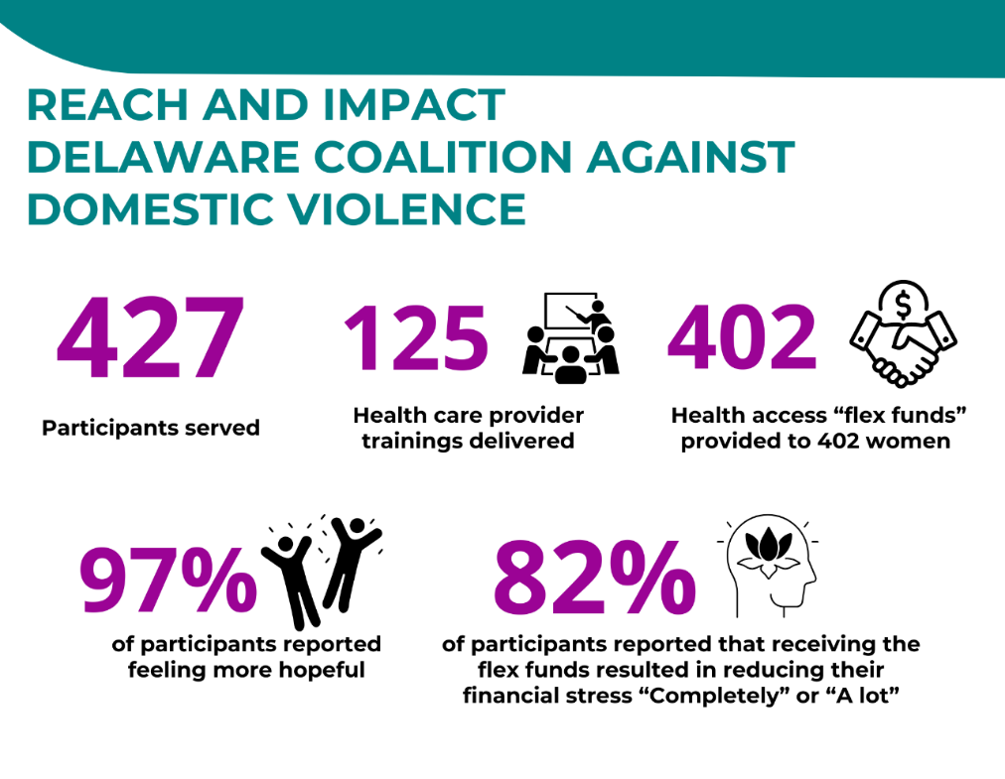
*Source: DCADV administrative and survey data, Delaware, 2021-2023

Delaware Multicultural and Civic Organization

The Delaware Multicultural and Civic Organization (DEMCO) was funded by the HWHB Initiative to provide academic and life skills supports and job training education to young women of childbearing age, including those who are pregnant and parenting, who are living in Dover Zip Codes 19901 and 19904.
Delaware Multicultural and Civic Organization
Key Activities:
- Career and professional development training.
- Parenting/fatherhood education and support.
Intended Outcomes:
- Increased healthy life skills and improved economic status.
- Improve professional skills and job readiness..

Each woman served is matched with a mentor to provide social and emotional support. The program progresses through a series of educational workshops to develop hard and soft skills to better prepare them for gainful employment and a career in the IT field. The program also includes support for fathers/partners, including effective fathers/partner parenting lessons, and an opportunity to engage in job shadowing and internship placement.

DEMCO’s goals for their program are for participants to:
- develop increased knowledge about (and intentions toward) making healthy life choices and improving economic mobility
“The reason this program is attractive is because students can receive mentoring and coaching but also be in a safe haven. They can bring themselves and we can chart a plan for how they see their lives in five years, or ten years.”

Linda Hackett, Senior Vice President and Statewide Academy Director, Delaware Multicultural and Civic Organization
- increase technical and professional skills
- increase job readiness
- increase knowledge among students’ partners about how create a supportive learning environment.
In addition, given that many of the women served are caring for school-aged children, DEMCO utilizes the IT skills development activities to not only support their clients to prepare for a career in the IT field, but to also help those who are mothers to support their children’s remote learning. Since the COVID-19 pandemic began, an additional goal was added: to mitigate immediate needs related to social determinants of health among participants served based on the provision of flex funding.

DEMCO’s evaluation focuses on understanding the effectiveness of the program at helping women develop healthy life skills and prepare for economic mobility.
Table 13: DEMCO Participants, Delaware, 2020-2023
Participants per Cycle
Cycle 1 | 91
Cycle 2 | 43
Cycle 3 | 67
Cycle 4 | 90

*Source: DEMCO administrative data, Delaware, 2020-2023
Reach
DEMCO has served 291 participants between January 2020 and June 2023. Most participants were African American (83%), 12% were White, 3% were Mixed/Multi-racial, and 2% did not provide this information. While 80% of participants were female, 20% were male. The topics of the classes and the participation in classes to date are shown in the following table.

Table 14: DEMCO Class Topics, Delaware, 2020-2023
Topic of Class | Number of Participants | Percent of women rated this service ‘Very Useful’, ‘Useful’, and ‘Somewhat Useful’
Academic, Life Skills, and Healthy Living Training | 233 | 78%
Keyboarding Education | 231 | 78%
Microsoft Office Skills Education | 231 | 78%
IC3 Computer Basics Certification Training | 189 | 49%
Workforce and Life Skills Readiness Support | 236 | 79%
Job Shadowing | 132 | N/A
Mentoring | 188 | 82%
*Source: DEMCO survey data, Delaware, 2021-2023

Impact
A Post survey included questions about the impact of the program and classes on participants. Data from the post survey were very positive. Over half of respondents saying the program was excellent, and three-quarters strongly agreed that what they learned will help them be successful in the future.

Questions included a focus on:
- perceived effectiveness of the program activities at helping participants develop healthy life skills, prepare for economic mobility, and be successful in the future
- the extent to which participants felt that the Effective Fathers and Partner Parenting lessons helped them and their male partners create a supportive learning environment at home
- satisfaction with services.
During the post-survey participants showed satisfaction with the services provided as well as personal development in confidence and communication.

Table 15: DEMCO Post-Survey Responses, Delaware, 2020-2023
Post-Survey Responses | Strongly Agree | Agree
Participating in this program increased my confidence. | 69% | 13%
Because of this program, I have gotten better at communicating my strengths. | 71% | 13%
This program helped me identify and understand my skills. | 70% | 13%
Because of this program, I developed new skills that helped me be successful. | 69% | 14%
While I was participating, I felt like an important part of DEMCO’s community. | 70% | 12%
I discovered career pathways aligned to my life goals. | 68% | 12%
Participating in this program made me even more committed to my educational and employment goals. | 68% | 14%
My mentor gave me feedback that improved my skills. | 71% | 12%
*Source: DEMCO survey data, Delaware, 2021-2023

Figure 10: Reach and Impact of the Delaware Multicultural and Civic Organization,
Delaware, 2020-2023
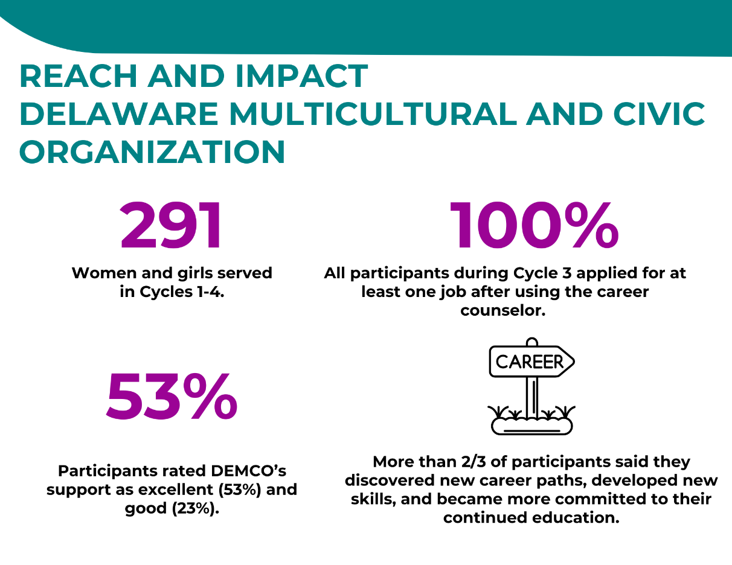
*Source: DEMCO administrative and survey data, Delaware, 2020-2023

Hispanic American Association of Delaware

Hispanic American Association
of Delaware

Key Activities:
- Provide parenting support groups during pregnancy and postpartum to reduce cultural stigma around mental health in the Latino population, provide support to families with recent migration and acculturative stress, provide art therapy, and offer referrals to insurance and other needed services.
Intended Outcomes:
- Reduce participant stress, anxiety, and depression.
The Hispanic American Association of Delaware (HAAD) provides pregnancy and postpartum support in Spanish to women ages 15-44 who live in ZIP Code 19720 in New Castle County.

In Cycles 1 through 3, support groups met twice weekly with pregnant and postpartum women to provide support, reduce cultural stigma around mental health in the Latino population, provide support to families with recent migration and acculturative stress, and offer referrals to insurance and other needed services. In Cycle 4, group nutrition and physical exercise sessions are typically held four times per week, and mental health support through art sessions are held weekly.

HAAD now has a building where they can host physical exercise and nutrition sessions several days per week. These have become the focus of Cycle 4, along with weekly mental health through art sessions.

The program also hosts a family network event to involve the whole family (especially fathers) and to connect the community to pregnancy and postpartum mental health resources. The program, called Mamas felices, hijos felices (Happy Mothers, Happy Children), has the goals of creating wellness, resilience, hope, and connection for women adjusting to parenthood and experiencing pregnancy and postpartum emotional ups and downs.

HAAD has been measuring the degree to which participation in activities reduces participant stress, depression, and anxiety, as well as participant satisfaction with activities and services.

Reach
In Cycles 1 and 2, HAAD provided services to 104 women. In Cycles 3 and 4, HAAD has provided services to 350 women as program enrollment and services offered have continued to grow over the course of implementation.

Figure 11: Services Provided and Participants in the Hispanic American Association of Delaware, Delaware, 2020-2023

*Source: HAAD administrative data, Delaware, 2020-2023

In addition to serving more women than in Cycles 1 and 2, participants in Cycles 3 and 4 are receiving more services, including individual sessions. Group sessions have evolved to include meetings focused on nutrition and physical activity, and mental health support through art. In Cycles 1 and 2, only group support sessions were provided. After HAAD heard feedback from participants in Cycles 1 and 2 about additional services that would be useful, they added individual sessions as a service. As a result, 209 individual support sessions were provided in addition to the 471 group support sessions.

Table 16: HAAD Participants and Services, Delaware, 2020-2023
Cycle | Number of Women Served | Group Sessions Provided | Individual Sessions Provided | Total Sessions Provided
Cycle 1 | 48 | 48 | 0 | 48
Cycle 2 | 56 | 45 | 0 | 45
Cycle 3 | 87 | 84 | 110 | 194
Cycle 4 (through June 2023) | 159 | 294 | 99 | 393
Total | 350 | 471 | 209 | 680
*Source: HAAD administrative data, Delaware, 2020-2023

Impact
To measure progress toward the goal of reducing stress and anxiety, HAAD uses a modified version of a validated scale, the Depression, Anxiety, and Stress Scale (DASS). DASS is used before a participant uses services and again after the last session. In all three cycles, reductions in stress from pre- to post surveys were statistically significant, suggesting that the program reduces stress, anxiety, and depression among participants.

Figure 12: HAAD DASS Scores of Participants, Delaware, 2020-2023
*Source: HAAD administrative data, Delaware, 2020-2023
“Our vision was to improve health...we see the impact of mental health, trauma, ACES, and also misinformation. One of the years one woman spoke about reading nutrition labels. Lots of people are diabetic or pre-diabetic and are very young. This can be delayed or prevented with the right information and education. That’s why ... we realized we needed to add a physical health dimension to our work. That has been very successful in the last period, adding exercise with music. Those habits are connected...They come, start doing exercises, start eating better – experience improvements in their mood. They find in the other women people they can share their successes and difficulties with. They start cooking better, shopping better. Children have better health too. Because of how important women are for any changes within the family unit, we think it’s very smart for an organization wanting to improve the health of a community to focus on women and moms. As they do, learn, and improve, everyone does.”

Ronaldo Tello, Ronaldo Tello, Ph.D., Executive Director,
Hispanic American Association of Delaware

Figure 13: Reach and Impact of the Hispanic American Association of Delaware, Delaware, 2020-2023
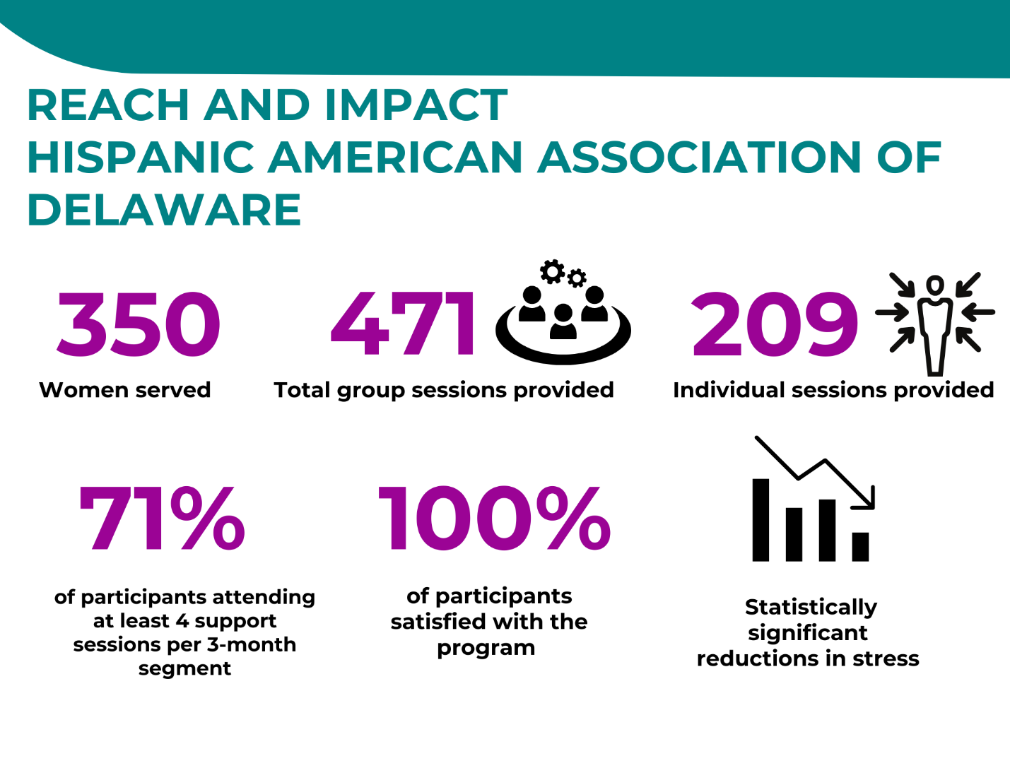
*Source: HAAD administrative and survey data, Delaware, 2020-2023

Impact Life

Through the HWHB Initiative, Impact Life is providing a pilot program of a pop-up, community-based, cashless grocery “store” that is modeled on the successful “Greater Goods” program in Philadelphia. A cashless grocery store allows individuals to shop without the stigma and fear associated with a food closet model. This program takes a novel approach to addressing hunger and food insecurity by allowing individuals to select their own food, offering a wide variety of healthy food options, and providing on-site skill building classes and case management services, similar to the “More than Food” framework.
Impact Life
Key Activities:
- Pop-up cashless grocery “stores”
- Consultations with nutritionist
- Meal planning and recipes
- Case management and referrals.
Intended Outcomes:
- Reduce food insecurity
- Improve access to healthy food options and nutritional education
- Improve physical health.

Program Activities
Impact Life offers food distribution events that are bi-weekly pop-up, community-based, cashless grocery “stores.” Individuals who attend a food distribution event are given and allotted tokens to use to shop for nutritious food items. A nutritionist is present to assist individuals with making healthy selections. The nutritionist will also assist with healthy meal planning and preparation. A case manager is also present to connect individuals to any needed services, including connection to breastfeeding educators, WIC, and other infant feeding resources.

In rural areas, individuals can sign up for bi-weekly food distribution and delivery. This reduces transportation barriers and the shame that can be associated with food insecurity. Additionally, education and nutrition programming is offered in-person and virtually. This includes education for individuals about how to grow their own food at home and make nutritious meals.

Reach and Impact
Because the program is in its early stages of data collection, impact data are not yet available. However, data on the reach of the program are promising. In its first 18 months of funding, Impact Life provided services to hundreds of people. Over 400 people attended the pop-up grocery stores and 176 received food deliveries. Nutrition counseling sessions were provided to 171 people; meal plans and recipe cards were given to 218 people; and 28 people attended education sessions.

Table 17: Impact Life Participants and Services, Delaware, 2022-2023
Zone 1 Activity | Number
Pop-up Grocery Stores | 26
People who attended grocery stores | 402
Nutrition counseling sessions provided | 139
Meal plans created | 218
Recipe cards provided | 218
Zone 3 Activity | Number
Food deliveries completed | 120
People who received food deliveries | 176
Number of food boxes provided | 120
Beginner gardening kits distributed | 110
Nutrition counseling sessions provided | 32
Education sessions provided | 28
People who attended education sessions | 28
*Source: Impact Life administrative data, Delaware, 2021-2023
Figure 14: Reach and Impact of Impact Life Inc., Delaware, 2022-2023
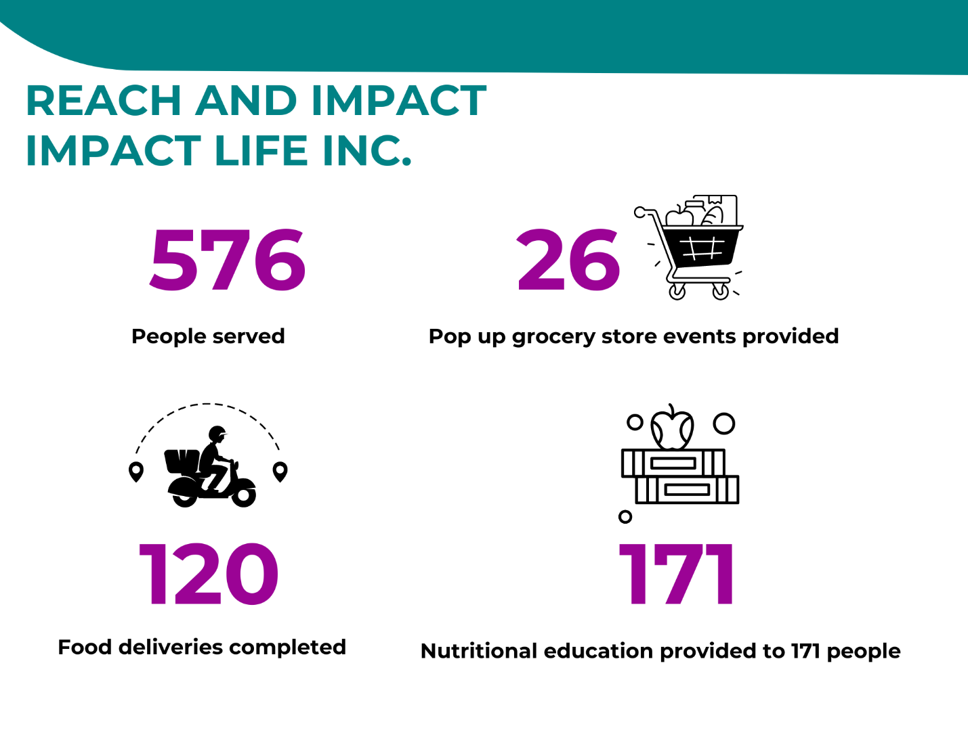

Parent Information Center

The Parent Information Center (PIC) provides program management for the Sussex County Community Doula Program. PIC seeks to serve parents and professionals through technical assistance, doula certification training, webinars, newsletter information, and pregnancy and postpartum support groups.

Parent Information Center
Key Activities:
- Doula training and certification program
- Educational webinars for doulas, doula candidates, and the general public.
Intended Outcomes:
- Increase awareness about doulas
- Increase the number of trained local doulas, particularly women of color.

Program goals are to increase awareness about the benefits and availability of community-based doulas, about how to provide doula services. Desired outcomes are to increase the number of local doulas trained to deliver childbirth and postpartum services in their communities, and to increase client satisfaction, knowledge about doula services, and attitudes towards using a doula. These goals contribute directly to the HWHB Initiative’s overall goals to improve maternal and infant outcomes among women of color in Delaware and to address maternal and infant health disparities.

Program Activities
To achieve these goals, PIC provides a doula training and certification program, as well as education for the general public and for doulas.

Doula Certification Program
PIC provides a doula training program, with a focus on training people of color who reside in Seaford, Delaware. The program includes training on pregnancy, childbirth, and postpartum concerns and techniques for comfort and support. Throughout the three years of the HWHB Initiative, PIC provided several recognized perinatal and doula certifications, including Stillbirthday, DONA, and Commonsense Childbirth Institute. After participants are trained, they immediately begin working with families. Certification through DONA requires three birth experiences, and the doula stipend program provides some funding for the doulas as they are meeting this requirement.

Webinars
PIC provides outreach, training, and technical assistance to doulas and the general public monthly. Webinars and event/information sharing through a weekly PIC electronic newsletter distributes information about resources available to families during pregnancy, childbirth, and postpartum. Participants can attend live webinar presentations or watch recorded webinars through the PIC online portal. Additionally, there are at least two community resources shared monthly through PIC’s marketing and social media accounts.

Reach and Impact
Doula Training
Through its funding from the Healthy Women, Healthy Babies Initiative, PIC has provided doula training to 82 women. The vast majority (90%) of participants who provided their race/ethnicity were women of color. A total of 40 women have received doula services from the women who were trained by PIC. For eight of these women who were served by the doulas, this was their first baby.

Satisfaction with Doula Services
The women who received services from doulas trained by PIC were asked about their experience with the doula. Questions covered the support and education provided by the doula to the woman and the partner; whether the doula was a helpful addition to the team; whether the doula contributed to a positive birth experience; and whether they would recommend the doula to others. While only a small number of the women who received doula services responded to the survey, responses were all positive.

Webinars
PIC conducted eight webinars during the HWHB initiative, with 81 total participants. The webinars provided information about pregnancy, childbirth, and postpartum; and explained what a doula is and how they support families. The webinars also focused on ways that doulas support the broader community and how culture and religion impact a birth or postpartum experience.

Table 18: Knowledge Gained from Parent Information Center Webinars, Delaware, 2021-2023
Question | Pretest Mean | Post test Mean | T-Test Results
I know where I can go to find out more information about pregnancy, childbirth, and postpartum. | 3.14 | 3.71 | p=0.00*
I understand what a doula is and the support they provide families. | 3.28 | 3.64 | p=0.05*
I can name two different ways doulas support the community. | 3.21 | 3.71 | p=0.03*
I understand how cultural and religious differences can affect a birth or postpartum experience. | 3.00 | 3.64 | p=0.01*
I can list some common early pregnancy complaints. | 2.57 | 3.90 | p=0.00*
I can identify two resources for information about early pregnancy health. | 2.89 | 3.76 | p=0.00*
I know two ways a community doula can support a person in early pregnancy. | 1.88 | 3.90 | p=0.00*
*Significant at .05; Source: PIC survey data, Delaware, 2021-2023

After attending the webinar, webinar participants were asked to describe their knowledge about what a doula is and does, how to provide support, where to find more information, and about important cultural and religious components to the pregnancy and postpartum experience. Participants reported very high levels of knowledge and comfort with these concepts. Changes in knowledge from pre-webinar to post webinar were statistically significant.

Figure 15: Reach and Impact of the Parent Information Center, Delaware, 2021-2023
*Source: Parent Information Center administrative and survey data, Delaware 2020-2023
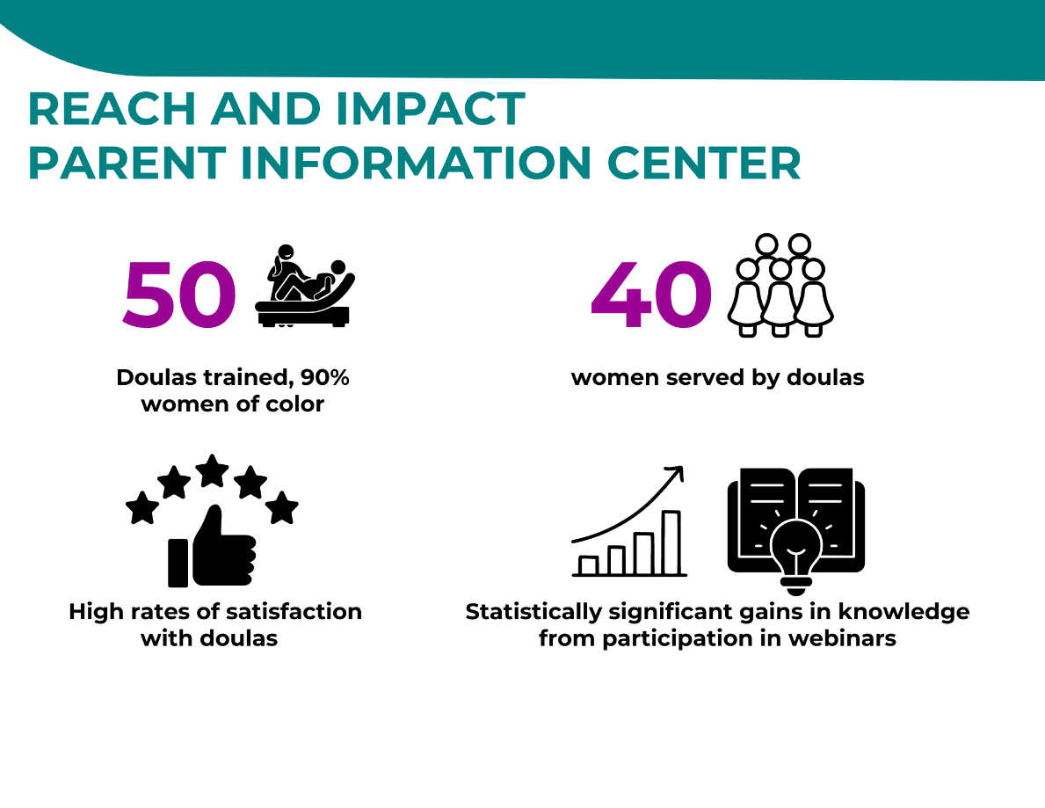

Reach Riverside Development Corporation

Reach Riverside Development Corporation (Kingswood) was a mini-grantee in Cycles 1 and 2. They proposed to provide targeted services (at the Kingswood Community Center) designed to reduce toxic stress to women of childbearing age and their partners including: a multi-generational maternal and child health program, referral and resource services, case management, workshops and training, including workshops to increase fatherhood/partner engagement. Because of challenges with startup, the REACH program reduced its program and shifted focus to provide Flex Fund to parenting mothers to secure basic need items and to offer the fatherhood/partner engagement component.
Reach Riverside
Development Corporation
Key Activities:
- Fatherhood/partner engagement
- Flex funds to mothers
Intended Outcomes:
- Improve fatherhood engagement and skills
- Improve access to basic need items

Reach and Impact
Twenty-six men participated in the “Every Man Counts” workshop series and 16 men participated in the “24/7 Dads” workshop series. Some men attended both. Additionally, five men who took either workshop series were provided with case management sessions. All 26 men were Black/African American and between the ages of 15 and 79. About two-thirds were fathers. Those who were not fathers were age 19 or younger. A total of 12 men were married or had a partner.

At the end of the workshop series, participants were asked to compete a survey. Results for both were very positive. All respondents rated the course content, instructor, and overall quality of the course as excellent. Nearly all survey respondents strongly agreed that they learned new things and that the course was helpful to them as a father or future father. Nearly all respondents indicated that they will use what they learned in their daily lives, and that they have become better fathers as a result of the course. All strongly agreed they would take the course again and will recommend it to others.

Figure 16: Reach and Impact of the Reach Riverside Development Corporation, Delaware, 2020-2023
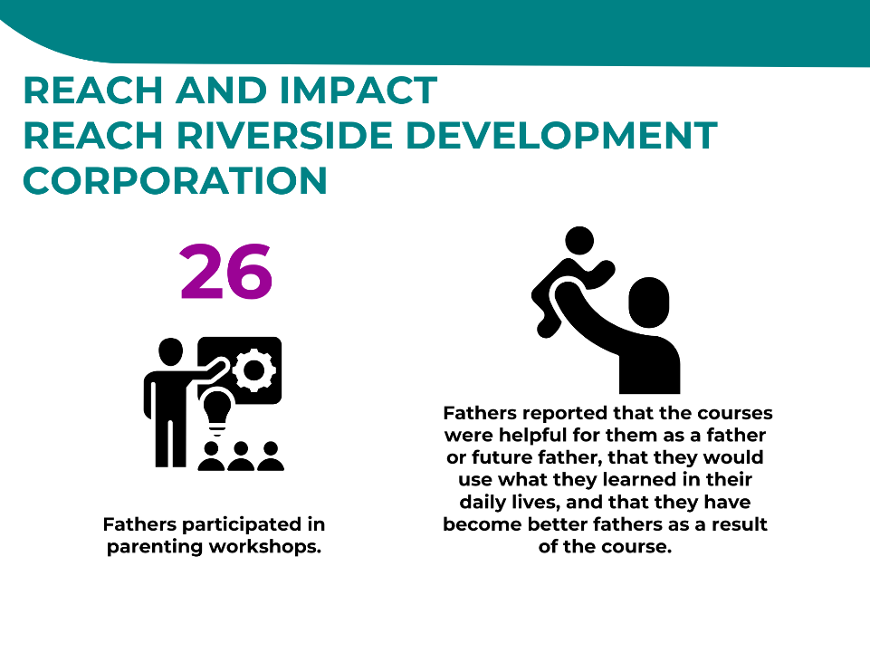
When asked about the most helpful things about the course, one participant said: “It made me become a better father and helped me get involved more with my community.” Another said it helped him “get knowledge of what being a future father really means.”

At the end of Cycle 2, REACH Riverside decided not to pursue continued funding, but to focus on internal capacity building.

*Source: Reach Riverside administrative and survey data, Delaware 2020-2023

Rose Hill Community Center

Under the HWHB Initiative, the Rose Hill Community Center has two separate but related programs: Women’s Wellness and Stress Reduction. The Stress Reduction program was added in Cycle 3, while the Women’s Wellness program was part of Cycles 1 and 2 and continued in Cycles 3 and 4. Of note, Rose Hill Community Center also plays a large role in facilitating the Guaranteed Basic Income pilot program, discussed earlier in this report.

Rose Hill Community Center

Women’s Wellness Key Activities:
- Fitness classes
- Nutrition classes
- Self-improvement classes.
Intended Outcomes:
- Increased participation in physical activities
- Increased knowledge, attitudes, and intentions towards nutritional food options
- Increased knowledge, attitudes, and intentions towards mental wellness
- Reduced stress.

Women’s Wellness
The Women’s Wellness program provides fitness classes, nutrition classes, and self-improvement classes to women of childbearing age in New Castle County who reside in ZIP Codes 19720 and 19801. These classes are offered at no cost. Offerings include:

- Fitness classes: yoga, Zumba, cardio kickboxing
- Health classes: nutrition classes, plus one-on-one appointments with an on-site nurse. Participants also have access to an on-site mental health consultant who is a National Certified Counselor and Licensed Professional Counselor.
- Self-improvement classes: stress management, positive self-image, combating negative attitudes, conflict management, effective communication, professionalism
- Parenting classes: Parenting 101, couponing, social media, discipline verses punishment
- Financial classes: financial literacy, community resources, and goal setting.
Free childcare is available during classes. Fitness activities and other services are tailored to pregnant and other participants with specific needs through meetings with a nurse and Women’s Wellness Program staff.

“I grew up there [Rose Hill], my children pretty much grew up there. Now that I’m older, I see the end result…as far as what the program has offered to me, my children, my family. Because I stuck with it, I created healthy habits not just for myself, [but for my family].”

Women’s Wellness Program Participant
“As a whole, there is no way that you can walk away from the program without learning something. Whether it’s remedies, eating proper foods, what you should be eating, when you should be eating, exercising. I really can’t think of any negatives about the program.”

Women’s Wellness Program Participant
Stress Reduction
The Stress Reduction program provides the following services to participants, with a primary goal of reducing stress:
Rose Hill Community Center
Stress Reduction Key Activities:
- Workshops
- Yoga
- Massage
Intended Outcomes:
- Reduced stress levels
- Increased knowledge about and intentions to use stress coping skills
- workshops (such as classes that teach breathing exercises to manage stress)
- weekly yoga classes
- journal writing
- mental health stress relief workshops (self-care, recognizing depression, anxiety, asking for help, creating goals, knowing when to say “no”)
- massage
Participants receive monthly communication that shares tips from the mental health consultants, a housekeeping tip, and a healthy habit tip.

The primary evaluation questions for both programs are:
- Will services help reduce the stress levels of participants?
- Will services improve the health (and reduce the health disparity) of participants?
Reach
In the first three years of the initiative, 80 women participated in the Women’s Wellness program. Fifty-one of these women also participated in the Stress Reduction program. The same 80 women participated in fitness classes 12,330 times over all four Cycles (an average of 154 classes per woman). As of July 31, 2023, 64% of participants completed at least two fitness classes per month.

Overall, 80 women participated in nutrition classes 143 times through all four cycles (January 2020 through June 2023). In the Stress Reduction program, 38 women participated in workshops 159 times in the first 10 months. On average, each woman participated in four Stress Reduction workshops.

Participants attended yoga classes 324 times, which is about eight classes per woman. A total of 61 massages were done. Twelve participants did not receive a massage, but the other 26 received at least one, and most received two. A total of 13 mental health services were provided during Cycle 4.

Table 19: Rose Hill Participants and Services, Delaware, 2020-2023
Activity | Number of Participants | Number of Services Attended | Average Services per Participant
Fitness Classes | 80 | 12,330 | 154
Nutrition Classes | 80 | 143 | 2
Stress Reduction Workshops | 38 | 159 | 4
Yoga Classes | 41 | 328 | 8
Massage | 26 | 61 | 2
Mental Health Services |  | 13
*Source: Rose Hill administrative data, Delaware, 2021-2023
Impact
To measure progress toward their short-term outcomes, Rose Hill collects data on several health measures, including participants’ changes in diet and water consumption, self-reported benefits from participating, and weight changes. Notably, as of July 31, 2023, 28% of participants lost more than eight pounds after 16 months in the program.
“At the beginning of the [Women’s Wellness] program, the women were all in silos, but now since it’s been three years, they’re like a family. Everybody is coming together, holding each other accountable to be active in the fitness classes, and the mental health workshops...It’s a sisterhood.”
Dara Dupont, Deputy Director, Rose Hill Community Center

Additionally, the program administered the Perceived Stress Scale (PSS) 12 times across all cycles and one time during Cycle 4 (January 2023). The PSS includes 10 questions designed to measure a respondents’ perceived stress over the past month.

Individual scores on the PSS can range from 0 to 40, with higher scores indicating higher perceived stress. Scores ranging from 0-13 are considered low stress, 14-26 are considered moderate stress, and scores ranging from 27-40 are considered high stress. A total of 48 participants took the self-reported stress survey in November 2019, just before the program began, and then again in June 2023. The mean scores for these participants went down from 13.88 before the program began to 10.81 after 3.5 years of participation in the program. This was a statistically significant change in self-reported stress.
“Offering these programs can change someone’s life. Having the opportunity to meet with a mental health consultant, having free fitness classes, those things are important to people in this community.”
Dara Dupont, Deputy Director, Rose Hill Community Center

Figure 17: Reach and Impact of the Rose Hill Community Center, Delaware, 2020-2023
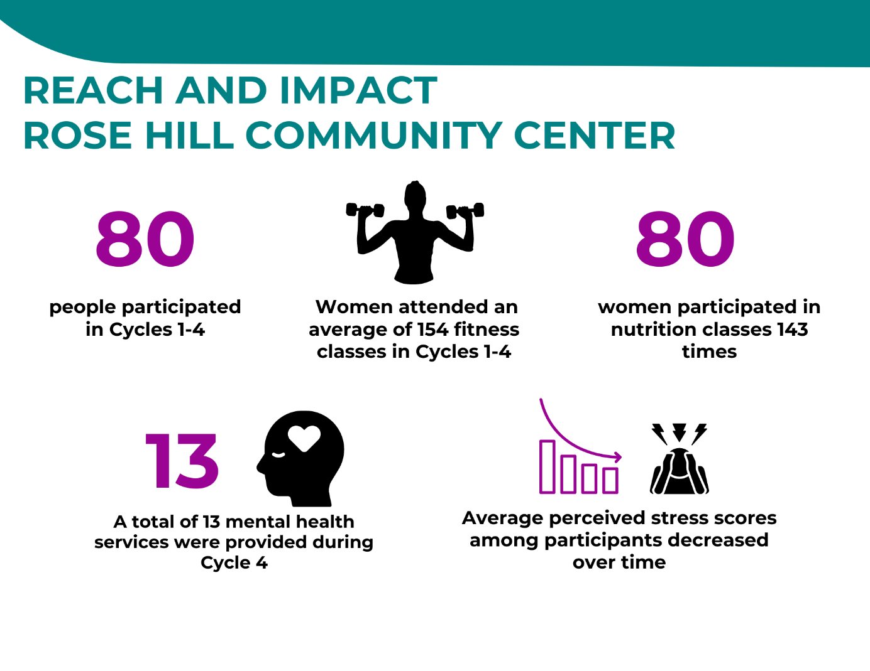
*Source: Rose Hill Community Center administrative and survey data, Delaware, 2020-2023

Guaranteed Basic Income Demonstration

Overview of the Program
In January 2021, as an expansion of the Healthy Women, Health Babies (HWHB) Initiative, the State of Delaware began implementation of a Guaranteed Basic Income (GBI) Demonstration program for pregnant women. The Demonstration was created with input and support from the Delaware Department of Health and Social Services, the SDOH subcommittee, and the DHMIC. Community partners for this initiative include the Rose Hill Community Center, the Delaware Coalition Against Domestic Violence, and Stand by Me, all of which provide services and support to the participants.
The GBI Demonstration provides $1,000 a month in the form of a debit card for two years to women who enroll during their first or second trimester of pregnancy. They have incomes less than the federal poverty line. Forty women are enrolled in the Demonstration. Participants also receive linkages to, and guidance on, prenatal care and post-partum care, financial coaching, and referrals for primary health care, mental health, and personal health and wellness. GBI is part of Delaware’s HWHB Mini-Grant Initiative, a free program for pregnant women at risk of poor maternal and infant health outcomes.

By providing this funding, these services and linkages to others, the GBI Demonstration is designed to reduce stress, improve physical and mental health of participants and their children, and improve maternal and infant birth outcomes. Additionally, the Demonstration is designed to reduce utilization of emergency departments and decrease hospitalizations, and to increase financial stability, housing stability, and employment stability.

To measure these outcomes, the study included multiple methods, including analyses of data on spending of the stipend, quarterly surveys with participants, two rounds of interviews with participants, and analyses of cost and savings data to assess Return on Investment.

Findings
Over the course of the 18-month GBI Demonstration, participants spent their stipend on basic necessities: food, household items, transportation, rent, Internet and phone, clothing, utilities, insurance, childcare, and personal hygiene.

Table 20: Spending Data for GBI Participants, Delaware, 2022-2023
Category | Percent of Spending
Restaurants, Groceries | 27-30%
Household | 8-11%
Gas, Automotive, Transportation | 9%
Rent (including cash/money transfers) | 7%
Internet, phone | 9%
Clothing | 6%
Utilities | 3%
Insurance | 2%
Childcare | 2%
Personal Hygiene | 2%
Entertainment | 2%
Unclassified | 9%
*Source: GBI administrative data, Delaware, 2022-2023

Outcomes
Health and Stress
Participants’ physical and mental health improved throughout their participation in the Demonstration. Out of the last 30 days, the number of self-reported days when their physical health was not good went down from 1.4 days (at pretest) to 1.1 days (after being in the program for nine months), as did the number of days of poor mental health (from 5.6 days to 4.8 days). The number of days that poor health prevented participants from engaging in their daily activities also went down (from 4.0 to 3.0 days).

Utilization of the emergency department (ED) and hospitalizations over the past 12 months also fell substantially.
- Self-reported ED visits: 1.75 at the pretest to .61 after being in the program for nine months
- Self-reported hospital stays: 1.17 at pretest to .59 after being in the program for nine months
Levels of perceived stress also dropped from 3.07 at pretest to 2.79 after being in the program for nine months. While this change is not statistically significant (likely due to the low sample size), it is a promising trend.

In the fall of 2022, HMA interviewed 26 participants in the GBI Demonstration by Zoom or by phone to learn about their experiences with the program and about how the program impacted them. Women were asked about their overall experience with the program and accessing funds, their experiences with case managers and financial coaches, and if the program is bringing any benefit to their lives. The women were also asked if there were any challenges and if they would make changes to the program.

Accessing and Using the Funds
The majority of participants said it was easy to access their funds twice a month. However, some participants reported experiencing issues such as late payments and not being able to use the card for rent. Some participants who pay their rent via cash or check initially were not able withdraw cash from the program’s card to fit their landlord’s requirements (cash, check, Venmo, etc.). When asked about the impact late payments had on them, one participant stated:

“When you are depending on it, yes, you might need it early in the morning for transportation. It might not come till 12 or 2. Sitting there banking on the money, might find yourself borrowing. When you’re depending on it, yeah, it kinda hinders you. Some of us, it’s all we get, it’s all we have.”

Participants said they have a good understanding of program expectations, noting that Ms. Dara at Rose Hill Community Center and others have thoroughly explained the requirements around using the funds. Some participants asked questions such as whether using funds in certain ways would jeopardize their ability to participate in the program (i.e., buying clothes at a particular store).

Financial Coaching
Participants reported either being in regular contact with their financial coach and benefitting from it; or having trouble staying in contact with their financial coach. A few participants spoke very honestly about their hesitation speaking to a stranger on the phone about their personal finances.
Most participants reported that their financial coach was very helpful with topics such as improving their credit score and creating a budget and savings plan. Participants spoke about learning new financial skills. With help from a financial coach, one participant was able to purchase a house. Financial coaches connected participants to the following resources: electric, water, the Delaware Housing Assistance Program, Toys for Tots, and more.
“Yeah, it has been helpful, I feel like she gives a lot of advice on the next steps as far as my credit is my major thing that I am working on now, she gives me the next steps on what I need to do, that is what I have been working on the last few months.”
“I feel like during the pregnancy I just had a lot going on mentally, so I was not grasping the whole narrative of having a financial coach, but now that I am getting more equipped with my schedule and now I am starting to see what the future is looking like, I am starting to take it more seriously.”
“They are pretty good with having conversations, and reaching out every three months, with resources and being able to sit down and talking about goals.”
“Honestly, I was not taking advantage of it but now I am, so I think it is pretty helpful.”

A few participants said they struggled to stay in contact with their financial coach. Some participants said they did not see the value in having a financial coach and were actively avoiding making an appointment. A couple of participants thought the financial coaches want to meet too frequently and said the coach did not have enough to talk when they meet.
“My financial coach, I don’t know why, but it’s like we are always playing phone tag. It’s like we’ll schedule a meeting or a phone conference zoom again and she doesn’t call. I don’t know if, you know communication is not there.”

Feedback from these interviews was used to improve and further enhance financial coaching services, including communication between coaches and participants.

A few participants expressed discomfort sharing their personal finances with a stranger, especially considering the coaching sessions occur on the phone or over Zoom. Participants suggested a need for recognizing varying financial perspectives and values across cultures; and recognizing that there is general discomfort to discuss financial information.

“I am going to take the blame on it, at first, I was not comfortable talking about my finances, I am the type of person, if I avoid this maybe it will disappear, I wanted to accommodate her, but I did not stress.”
Case Management
All participants reported being in contact with their case managers. Most spoke about their positive close relationships with their case managers, who are often available almost 24/7 via text and phone to talk about anything. While not all participants have a close relationship with their case manager, they all were in contact with them and received referrals to resources. Such resources include: WIC, food assistance, rental assistance, child support information, DEHAP, food banks, career information, breast feeding classes, giveaways, the Low-Income Energy Assistance Program (LEAP), daycare information, English classes, and Head Start.
“She has been really good; all she does is listen and if she has an opinion she is really authentic. She is really nice. She has been sending me links as far as issues I have been going on, backtrack and see if I got information, I don’t remember a lot of stuff being pregnant she is always reminding me, her job to remember some of the things we talk about.”
“My case manager will send me different resources and help with the baby, and like different programs and everything. We will talk like once a month, and I will update her on everything that’s been going on, she’s been helping me save. I’ve saved so much money now since that I started back working, so I am really thankful for her.”
“Even when it is a later time she will accommodate me, her phone is open and I have her stored in my phone. I know she is available.”
Other Positive Impacts
Participants spoke about the different positive impacts the program has had on their physical, mental, and financial health and well-being. Many participants are not able to work or are working significantly less [since being pregnant and giving birth]. Many participants do not have maternity leave. The program’s funding allows them to take time off and rest before and after giving birth. Some participants have high-risk pregnancies, so the ability to take time off is critical. Participants spoke about having lower stress levels because they can count on the money and have their basic needs covered. Participants described the program as giving them “peace of mind” and “taking a weight off my shoulders.”
“Personally, I was going through a lot, this was the first pregnancy I went through by myself. When I heard about the program and got accepted into the program it was a gift from God, this personally for me it has been a very, very, very helpful piece to the package for me because I have no help.”
“It’s been great for my mental health, when it comes to finances it can be very stressful. So, I just say it’s been my mental health that has been much clearer and sustainable.”
Participants also said they are better able to provide for all their children. Participants spoke about being able to send their older children on field trips, take the family out to eat when they do well in school, buy clothing for their children, and prepare items for their new baby. Participants described feeling like they are better providers for all their children by having additional funds.
“It’s a blessing, less stressful, you’re not counting everything out, you’ve got a little room to breathe. So, it’s definitely a blessing.”
“It is helping all around, I have been able to do much more providing, put some big smiles on their face, I am grateful.”

Program Improvements
The most common challenge participants described was not being able to easily use the funding for rent payments (via cash, check, Venmo). Some participants had landlords that require rent in cash or check.
“I can’t be the only person with a private landlord who doesn’t have a website where you pay.”
Based on this feedback, the program explored ways to provide other methods for women to pay their rent. Participants reported that was an improvement for them.
“Recently they have that taken care of and I’m extremely grateful because it makes my life ten times easier with paying right now.”

Summary of Interview and Survey Findings
Overall, most women receiving GBI funds described a decrease in overall stress and an improvement in their physical and mental health. Participants can make ends meet and be a better provider for all their children. Participants appreciate the close relationships they have built with their case managers and are meeting their personal and financial goals. Some women have found new jobs, bought homes, paid off debts, and improved their credit scores. While most participants had positive feedback, some women encountered challenges in the program.

Return on Investment Study
This section provides details about the direct and indirect benefits to the women and their babies, along with the impact on the local economy. The costs are based on data provided by staff leadership of the program. Both a benefit-to-cost ratio and Return on Investment (ROI) are calculated. This ROI shows how many dollars in benefits to the participants and the community emerge from each dollar invested in the initiative.

HMA obtained data and information for this evaluation from the following sources: a literature search; gathering up-to-date information about a range of government programs in health care and social services; broad-ranging quarterly surveys of program participants throughout the duration of the program; and information provided by the GBI staff.

- Direct benefits of the GBI program start with the $1,000 a month in guaranteed income. This provides benefits of $480,000 to the 40 GBI participants over the course of one year. All the figures below on the value of other benefits and costs are for one year.

- GBI participants working full-time average $32,784 in annual earnings. Those working part-time average $16,758 in annual earnings. GBI helps workers search for work, prepare for work, and identify job opportunities. Based on the self-reported hours worked and wages by participants, the model estimated that they experienced an increase in aggregate earnings of $441,349 over a period of one year.

- GBI participation also reduced food insecurity through direct support and other efforts. Examples of other efforts are: making an in-house food pantry available; and connecting participants to subsidized food programs such as the Supplemental Nutrition Assistance Program (SNAP) and the Women, Infants, and Children (WIC) program. Based on participant survey responses and information gathered by program administrators, combined with the estimated value of SNAP and WIC benefits from the Center for Budget and Policy Priorities, the estimated aggregate value across all participants of newly secured SNAP benefits is $51,000 and the aggregate value of WIC benefits is $22,680.

- A critical problem facing all parts of the U.S., Delaware included, involves the lack of safe and affordable housing. The GBI staff helped connect eight pregnant women and new mothers with safe and affordable housing that included Section 8 rental subsidies. The aggregate value of these supports is $66,048 for one year of the demonstration.

- Supplemental earnings are another important source of indirect benefits that help pregnant women and new mothers pay their bills and follow a path to self-sufficiency. An important earnings supplement is the Earned Income Tax Credit (EITC). The aggregate annual value of the EITC for women who gained EITC benefits as a result of participation is $20,186.

- The model also calculated the value to GBI participants of newly obtained Temporary Assistance for Needy Families (TANF) benefits, which provides cash assistance. Aggregate benefits across all 25 participants who gained TANF were $97,380.

- Total benefits accruing to the 40 mothers and their babies annually, including the direct GBI payments and the indirect benefits from the programs detailed above, were $1,178,642.

- In addition to these benefits to GBI participants, this study found important savings related to reduced use of ED care and reduced inpatient hospital admissions. Based on self-reported data compared to the year prior to joining the program, participants had on average approximately one fewer ED visit and one fewer inpatient hospitalization (these figures excluded hospitalization at delivery). Based on average estimated costs of these visit types, across 40 participants, total ED savings are $21,600 and inpatient savings are $229,520. The sum is $251,120. These savings will flow mainly to the Medicaid program, though they may also reflect benefits to participants in improved health, time saved, and hardship avoided through prevented visits and inpatient care.

- The total benefits to the State/federal government, via Medicaid savings, and the locality (in the form of the multiplier effect, explained below) equals $1,311,898.

- The grand total of annual benefits is $2,490,541.
Ripple Effects – the “Multiplier”
In addition to all the benefits to the participants explained above, there will also be favorable ripple effects as they begin to spend a large portion of their newly available GBI and their earnings, earnings supplements, and SNAP and TANF benefits. This ripple effect is called the “multiplier effect.” The multiplier effect is the overall change in spending as it flows into the economy.

Researchers at California State University Northridge (CSUN) developed a “community multiplier” by first estimating separate multipliers for each of categories of spending, such as food, rent, utilities, etc., and then weighting each industry multiplier by the percentage of service recipients’ income spent among these sectors of the local economy. This weighted average was calculated to be 1.9.
For this reason, we used a multiplier of 1.9. It was calculated for poverty reduction efforts in low-income neighborhoods and therefore is more applicable to the research for this project than a more general, theoretical multiplier.

Costs
The major cost of the GBI program is the value of the debit card benefits: $480,000 annually. The Delaware HWHB program leadership was very helpful in providing detailed cost data. The project managers calculated salary levels, adjusted by the proportion of time worked on GBI, for key members of the DPH staff who operate and manage the GBI program, including time spent annually by the DPH MCH Director/Section Chief FHS, the Bureau Chief, Center for Family Health and Epidemiology, a CDC MCH Epidemiologist, and a staff analyst. To this was added the value of employee benefits and overhead, as well as time spent by the administrator of the program at the grantee organization that enrolled and provided support to participants. The total staff cost was $107,947 annually. Thus, the total cost of the program on an annual basis is $587,947.

Benefit-Cost Ratio and ROI
The ratio of total benefits to total costs is 4.24 to 1. Thus, the grand total of benefits from the GBI program is more than four times the amount of the total costs of the GBI program. An ROI of 324% means that for each dollar invested in the GBI program, more than three dollars was returned. The ROI represents how much the benefits grew from the initial investment.

Conclusion
Delaware’s GBI program is a smart investment with a very sizeable, positive return for participants, the state, and the local economy. This program, which combines monthly cash grants of $1,000 in the form of a debit card plus a cluster of important wrap-around services, improves the health of pregnant women, new mothers, and their babies. It also connects the women to important social and economic benefits including employment, food security, and a safe and affordable home. GBI is also helping them achieve financial self-sufficiency and reduce stress and anxiety. The GBI program merits scaling up and replicating.

Conclusions and Next Steps
As the HWHB Initiative moves through its fourth year of implementation, evaluation data suggests it is achieving its intended goals. Participants report reduced stress, improved physical and mental health, stronger connections with communities that support them, improved relationships, and a better quality of life. The ROI study of the GBI Demonstration shows that its investment pays for itself more than three times over. As the Initiative moves into its fifth and final year of implementation in 2024, work to support healthy women and healthy babies across Delaware will continue. A final report will be developed and shared at that time.

Appendix A: National Best Practices to Improve Birth Outcomes and Reduce Racial Disparities

Delaware Continues to Face Racial Disparities in Maternal and Infant Mortality
In January 2023, the Division of Public Health (DPH) within the Delaware Department of Health and Social Services (DHSS) highlighted recent infant and maternal mortality trends in Delaware and nationally. In 2016-2020, Delaware’s infant mortality rate was 6.5 infant deaths per 1,000 live births, resulting in a total decline of 30.1 percent from the 2000-2004 rate of 9.3 infant deaths per 1,000 live births.. Racial disparities in infant mortality, however, have persisted; the infant mortality rate for non-Hispanic Black babies in 2016-2020 of 11.6 was more than three times higher than the rate for white babies of 3.8 deaths per 1,000 live births. The highest rate of infant mortality in Delaware was in the City of Wilmington and the overall lowest rate was in Sussex County. Critical disparities include:
- Increased postnatal neonatal mortality rate for Black infants (4.4 per 1,000 live births in 2017-21 compared to 2.2 per 1,000 in 2010-2014)
- Increasing infant mortality rate for Black infants in Kent County
- Increasing infant mortality rate for Hispanic infants in Wilmington
Premature birth is by far the leading cause of infant mortality in Delaware. In 2020 and 2021, one in nine infants were born preterm in Delaware (11.0% of live births).

Regarding maternal deaths, between 2018 and 2022, the majority of the 11 maternal deaths in Delaware were of women of color (Delaware Maternal Mortality Review, 2022).

Racial Disparities in Maternal and Infant Health are Worsening Nationwide
Pregnancy-related mortality rates among Black and Native American women are more than three and two times higher, respectively, than the rate for White women (41.4 and 26.2 vs. 13.7 per 100,000), as are rates of preterm births, low birthweight births, or births for which women received late or no prenatal care compared to White women. Black and Native American infants also have higher mortality rates than those born to White women. Maternal death rates and racial disparities for Black women increased during the COVID-19 pandemic, largely due to deaths caused by COVID-19. Black women had the highest maternal mortality rates during 2020 and 2021, and also experienced the largest increase compared to 2019. The maternal mortality rate for Hispanic women also increased, from less than the rate for White women prior to the pandemic to a similar rate in 2020 and 2021.

Recent Delaware Efforts to Address Infant and Maternal Mortality, Including Racial Disparities
In recent years, Delaware undertook a variety of efforts to reduce infant and maternal mortality and specifically target racial disparities in outcomes. These include:
- Enactment of the Delaware MOMNIBUS in 2022, a package of legislation to reduce maternal and infant mortality as well as racial disparities in outcomes, with a focus on expanding maternal and infant health care access in the state:
- House Bill 234 - extends Medicaid coverage through the first year postpartum
- House Bill 340 - provides updates to the Child Death Review Commission and name change to Maternal and Child Death Review Commission
- House Bill 342 - includes protections for pregnant prisoners regarding restraints
- House Bill 343 - requires Medicaid provide a plan for coverage of doula services
- HS2 for House Bill 344 - requires bias and competency training for health care workers
- House Bill 345 - provides access to doula/midwifery services for women in Delaware Department of Correction custody
- HB 80 Implements Medicaid coverage for doula care services for birthing people during pregnancy, labor and delivery, and postpartum by January 2024.
- Provided mini-grants through the Healthy Women Healthy Babies Mini-Grant Initiative to 10 community-based organizations to address the social determinants of health to implement place-based initiatives to achieve collective impact on health.
- The original health care provider-focused Healthy Women Healthy Baby Program (HWHB) has seven sites throughout the state that enroll high risk women in into preconception, prenatal, and interconception care. This program has impacted birth outcomes. HWHB-enrolled women were 10% less likely to smoke during pregnancy; were 9% less likely to deliver a low birth weight infant; and were 15% less likely to deliver a preterm infant as compared to women with similar risks factors but not enrolled with HWHB programs.
  - In 2019, the program transitioned to a performance-based model largely based on the Healthy Start initiative model with all providers focused on reaching or exceeding benchmark performance indicators to further improve outcomes for women and babies. Health care providers utilize evidence-based tools, protocols, and standardized messages and materials to help them improve services and support improved outcomes. - Women - Delaware Thrives (dethrives.com)
- Birth defects registry has monitored birth defects in Delaware and has shown no temporal increase in birth defects or higher rates compared to national averages
- The Delaware Pregnancy Risk Assessment Monitoring Program has revealed high rates of preconception maternal risk health risk factors for premature birth, including unplanned pregnancies and smoking. These findings allow targeted programming to improve health.
- Developed fetal/infant mortality and maternal mortality review committees to explore root causes of infant and maternal deaths in Delaware
- Developed a statewide education campaigns including: safe sleep campaign, “Long Live Dreams”, to help reduce unsafe sleep deaths in the first year of life based on AAP recommendations; My Life My Plan life planning tools, and contraceptive access awareness
- Delaware recognized as second top state for early breastfeeding indicators
- Developed Reproductive Life Plans to help Delawareans better plan their pregnancies and achieve optimal health before, during and after pregnancy
- Community Health Workers hired, trained, and deployed in HWHBs High Risk Zones
- Implemented a Guaranteed Basic Income demonstration program as well as a Housing Stability program for pregnant women
- Creation of a DHMIC Doula Ad hoc Committee chaired by Delaware State Representative Melissa Minor-Brown and Christina Andrews, community-based doula, to explore issues of integration of doulas into perinatal care during and after the COVID-19 pandemic. In collaboration with the DHSS Division of Medicaid and Medical Assistance, Delaware is planning, and working towards implementing coverage of doula services through Medicaid
- Delaware in the process of enacting 1-year postpartum Medicaid Coverage expansion.
- Delaware is implementing Medicaid coverage for evidence-based home visiting services focused on improving maternal and infant health. As a Maternal, Infant, and Early Childhood Home Visiting (MIECHV) Program federal grant recipient, Delaware supports a continuum of evidence-based home visiting programs including Nurse Family Partnership, Parents As Teachers, and Healthy Families America.
- Delaware has recognized Black Maternal Health Awareness Week since it started nationally in April 2019, inviting community members and health care professionals to participate in a variety of activities relating to Black maternal health, safety, and mortality.
- Formally recognized one individual and one organization annually for their work on health equity to improve health outcomes for moms and babies in Delaware
- Holds an annual conference with over 350 attendees that focuses on equity, racism, and social determinants of health and features national and local speakers and highlight accomplishments and innovative efforts
- Partnered with key stakeholders in Delaware, including Black Mothers in Power, Reach Riverside, faith-based communities, hospital systems, and Federally Qualified Health Centers on educational and clinical programming
- Participates as a key stakeholder with Delaware CAN initiative, leading to a seven-percentage point increase in moderately effective methods of contraception and a 17% increase in women indicating their pregnancy was wanted “then or sooner” in Delaware
- Established the Delaware Perinatal Quality Collaborative to improve and standardize hospital-based care including provision of antenatal steroids, care of neonatal opioid withdrawal syndrome, and reduction of post-partum hemorrhage
- Developed DEThrives.com website and social media platform (Facebook, Twitter, and Instagram) to further promote and educate consumers and professionals on DHMIC strategic priorities as well as maternal and child health initiatives, best practices, data, and programming
These efforts will continue to evolve in response to community needs identified through public health data collection and ongoing stakeholder engagement.

National Perspectives
Any analysis of health disparities and efforts to reduce them must acknowledge that they are historically rooted in racism and other forms of discrimination. Those are intertwined with other drivers of inequities including economic stability, physical environmental factors, education, food security, community safety, and health care resources (Figure 18).

Figure 18. Drivers of Health and Health Disparities

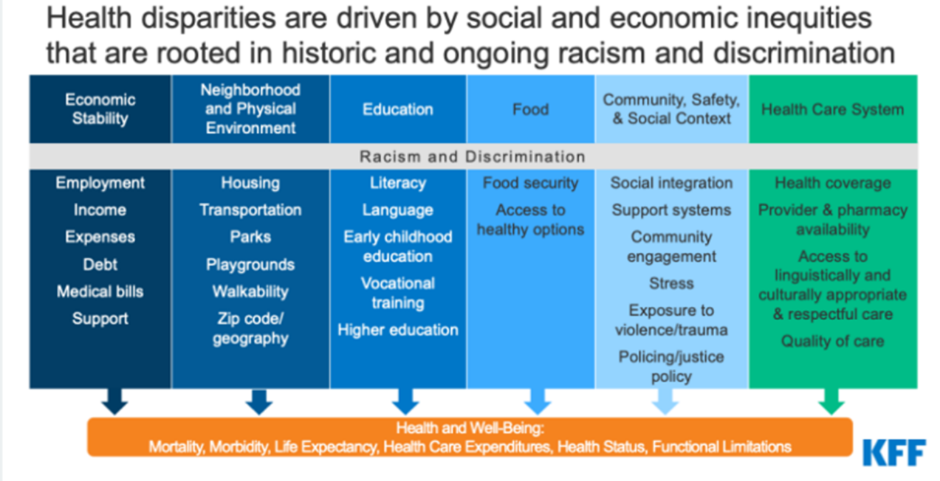
*Source: KFF, Racial Disparities in Maternal and Infant Health: Current Status and Efforts to Address Them. November
2022. Accessed November 2023.

Potential Pathways for Improvement
Potential pathways for improvement can be categorized in numerous ways, but one approach divides them by level of action, from large-scale public policy levers that may operate at the federal or state levels, to community-level programs with local focus. Health insurer or provider efforts may take place across those levels as well but are often at the organizational level and local. Of course, multi-stakeholder efforts can also span multiple pathways, approaches, programs, and stakeholders as they seek to improve birth outcomes and better meet people’s health and material needs. Each tactic or lever has potential impact on drivers of health but may also affect other parts of the system; all are part of a complex constellation of factors that contribute to birth outcomes, as shown in Figure 19 below.
Figure 19. Potential Pathways to Improve Outcomes and Reduce Racial Disparities
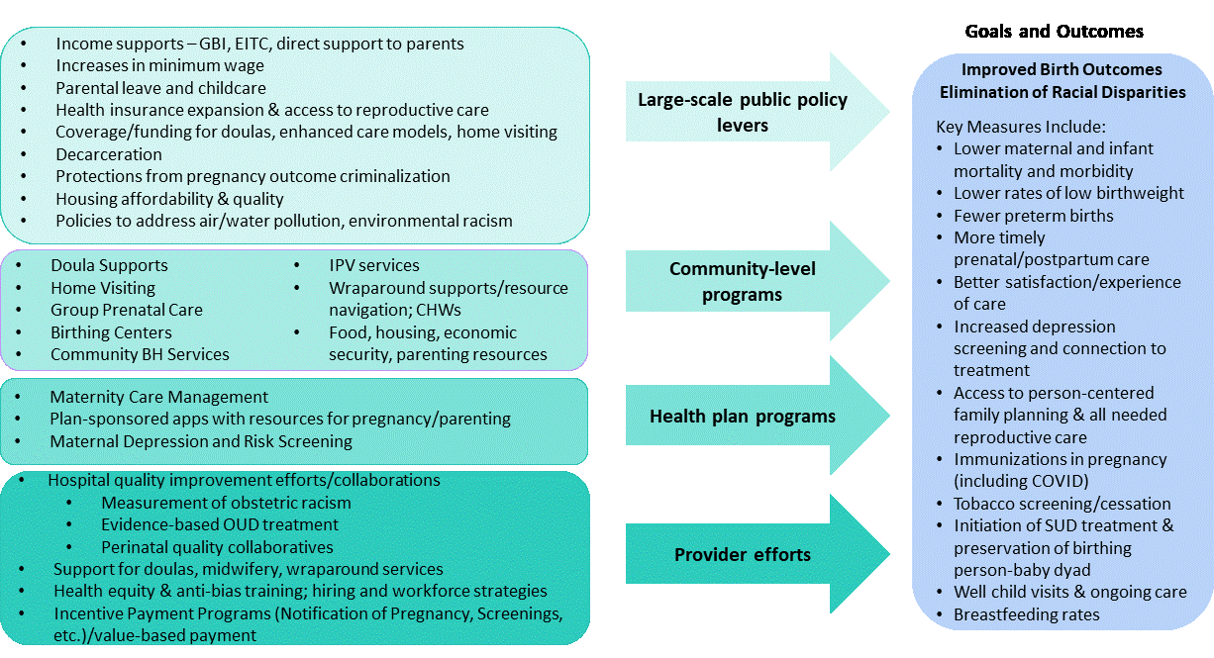
*Source: Health Management Associates, 2023.

The Evidence Base Continues to Evolve
A multitude of national, state, and local-level programs, strategies, and policies are being pursued across all categories and scales of intervention to support improved birth outcomes and work toward the elimination of racial disparities. Many have shown promise in improving outcomes, though no single effort can fully mitigate root causes that still need to be addressed at the largest scales of public policy and civil society. The Prenatal-to-3 Policy Impact Center identified 11 effective solutions that foster the nurturing environments infants and toddlers need (Figure 20).

Figure 20. Policies and Strategies Supporting Infant Health

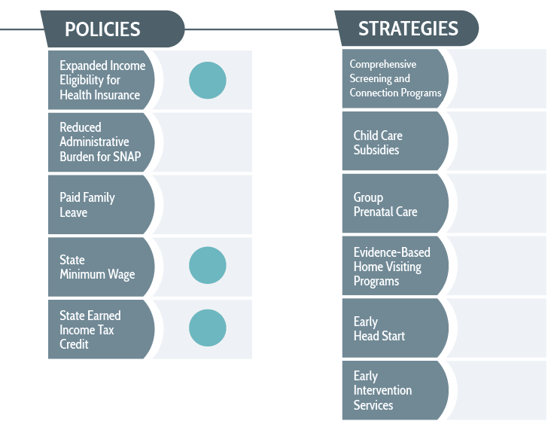
*Source: Prenatal-to-3 Policy Impact Center, 2022.

Three policies have demonstrated effectiveness at improving families’ access to needed services: expanded income eligibility for health insurance, state minimum wage increases, and increased earned income tax credits. In addition, strategies such as comprehensive screening and connection programs, child care subsidies, group prenatal care, evidence-based home visiting, Early Head Start, and early intervention services have been linked to outcomes, but the Prenatal-to-3 Policy Impact Center notes that the current evidence base does not provide clear guidance on how states should implement each strategy to improve outcomes. These strategies were implemented with substantial variation across localities and states, with varying resources, workforce capacity, and connection to other services that are needed to help women succeed. For example, screening pregnant women for housing needs without available housing options limits the effectiveness of enhanced screening and frustrates staff, participants, and organizations. State, local, and program-level administration of programs and policies often strongly influences their effectiveness.

Other promising strategies include:
- Perinatal Quality Collaboratives and Maternal Mortality Review Committees (PQCs and MMRCs) are statewide, multidisciplinary networks that promote evidence-based clinical practices by bringing key stakeholders together, producing issue briefs and strategic plans, and holding symposia and other events
- Participation in the Alliance for Innovation on Maternal Health (AIM), an alliance working to bring health improvement efforts for pregnant people at the national, state, and hospital level into alignment by providing hospitals with toolkits and bundles of medical information
- Implicit-bias training teaches medical professionals how to recognize and understand racial and cultural differences and biases, as well as how to interact with patients in a way that is sensitive to these differences and accommodates patients’ diverse needs (must be evidence-based/combined with approaches to impact patient care and has limitations).
- Funding doula services, such as through Medicaid to increase access to physical, emotional, and educational support for pregnant people
challenges measuring impact
Quantifying outcomes of state and local policy changes and programs using common evaluation methods is challenging:
- Collecting timely, high-quality data is always challenging, especially for smaller, local organizations with few staff.
- Since 2020, the COVID-19 pandemic has had myriad, disparate socioeconomic and health effects, some of which are harder to measure than others; the pandemic inequitably harmed women of color.
- Large-scale inequities and factors outside the scope of most state and local-level interventions influence outcomes for participants (e.g., states may offer income supports but larger federal child tax credits ended).
- Overturning of Roe v. Wade will widen disparities in maternal and infant health, have negative economic consequences for families, and increase risk of criminalization for pregnant people, particularly for people of color.
- More than 12 million people may lose Medicaid coverage in 2023-2024 as states begin redetermining Medicaid eligibility for the first time since 2020.
- At the same time, 29 states have adopted Medicaid postpartum coverage extensions to one year, with others in the process or likely to adopt expansions.
Input from participants and communities most affected is, as always, critically important in evaluating efforts to improve birth outcomes and eliminate racial disparities.
- Extending Medicaid coverage to 12 months postpartum. States can extend Medicaid coverage beyond the current federal minimum of 60 days postpartum. The increase of the eligibility for health insurance should improve health insurance coverage and maternal health outcomes during the postpartum period.
Also at the Federal level, the Health Resources and Services Administration (HRSA) in 2021 made significant investments in strategies that it views as priority approaches to reducing birth outcomes disparities, including:

- The MIECHV Program: $342 million in funding to 56 states, jurisdictions, and nonprofit organizations, building on the $40 million in emergency home visiting funds awarded through the American Rescue Plan in May 2021. Home visitors provide pregnancy education and parenting skill-building, offer supplies, and help families secure food, housing, and other support services.
- The Healthy Start Initiative: The Healthy Start initiative supports communities where the infant mortality rate is 1.5 times the national average. By working with women during pregnancy and after giving birth, these projects help reduce infant death and severe maternal illness. Every Healthy Start project has a Community Action Network composed of neighborhood residents, community leaders, consumers, medical and social service providers, faith-based leaders, and business representatives.
  - Community-Based Doulas: More than $3 million in supplemental funding was awarded to 25 Healthy Start grantees to increase the availability of doulas. Funding will cover the costs of training, certifying, and compensating doulas.
  - Infant Health Equity: More than $1.6 million in supplemental funding was awarded to 21 Healthy Start grantees to help reduce disparities in infant mortality in regional areas with the highest numbers of non-Hispanic Black or non-Hispanic American Indian/Alaska Native infant deaths. The funding will be used to create local action plans with data-driven policy and strategies, incorporating input from community members, consumers, and participants so the plans are tailored to the unique needs of their populations. The expectation is that programs will look beyond health care to address conditions that affect infant mortality disparities in their counties, such as poverty, education, housing, and nutrition.
Title V Maternal and Child Health (MCH) Block Grant: Approximately $2 million is awarded to Delaware annually and administered by DPH. The Title V MCH Block Grant is one of the largest federal block grant programs. Established under the Social Security Act, it funds 59 states and jurisdictions. The Title V MCH Block Grant provides funding to promote and improve the health and well-being of mothers, children, infants, and their families. States must match $4 of federal Title V funding by at least $3 of state or local funding.

State Systems Developmental Initiative (SSDI): Approximately $600,000 in supplemental funding was awarded to 10 grantees nationwide already participating in the SSDI program. The supplemental funding will expand the capacity of states and jurisdictions to collect and report timely, high quality maternal health data to support health care quality improvement activities, with a specific focus on the collection and use of data on race, ethnicity, and social determinants of health. DPH is a SSDI grant recipient.

Collaborative Improvement and Innovation Network to Reduce Infant Mortality (Infant Mortality CoIIN): Among Federal initiatives, the Infant Mortality COIIN is a multi-year national effort involving federal, state, and local leaders, public and private agencies, professionals, and communities to employ quality improvement, innovation, and collaborative learning to reduce infant mortality and improve birth outcomes. Focus areas include:

- SIDS/SUID/Safe Sleep: Improve safe sleep practices
- Smoking Cessation: Reduce smoking before, during, and/or after pregnancy
- Preconception/Interconception Health: Promote healthy birth spacing and reduce unintended pregnancy
- Social Determinants of Health: Incorporate evidence-based policies/programs and place-based strategies to improve social determinants of health and equity in birth outcomes
- Prevention of Preterm and Early Term Births: Increase appropriate use of 17 OH progesterone (17P), a hormone given to prevent pre-term labor, and/or reduce early elective deliveries (i.e., before 40 weeks). Many states have begun to limit access to 17 alpha hydroxyprogesterone caproate after conflicting clinical trial results. Until the Food & Drug Administration resolves the efficacy of 17P in reducing preterm deliveries, many states have paused promoting 17P utilization.
- Risk-appropriate Perinatal Care (perinatal regionalization): Increase the delivery of higher-risk infants and mothers at appropriate level facilities.
Most participating states found that these programs had an impact on outcomes. IM CoIIN evaluation results indicated that 78% of the states improved at least one outcome measure, and 43% of states reduced their infant mortality rate. The results of IM CoIIN also suggested that certain systems and infrastructure components (e.g., health department workforce, data capacity, partnerships) facilitated reductions in preterm birth rates. Other key findings from IM CoIIN programs include recent evidence of the impact of COVID-19 on birth outcomes. Pregnant people who are infected with COVID-19 and hospitalized are at risk for developing serious complications. They also have an elevated risk for delivering prematurely, miscarriage, and stillbirth, underscoring the important of preventive measures and testing. In addition, recent care delivery models have emerged, like group prenatal care (which has grown during the past 20 years), and telehealth. Mounting evidence informs the use of these and other models.
Case Study of an Impactful Multi-Stakeholder Network Advocacy Approach: B’More for Healthy Babies
B’more for Healthy Babies (BHB) works to reduce infant mortality in Baltimore city through programs emphasizing policy change, service improvements, community mobilization, and behavior change. It has helped reduce the infant mortality rate in Baltimore city to the lowest point ever. Outcomes are shown in Figure 21.
Figure 21: B’more for Healthy Babies Outcomes, 2017
Key elements include:
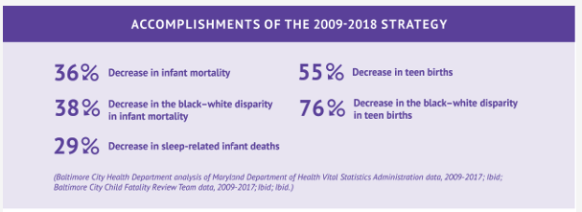
- Health care services improvements: BHB offers health care providers evidence-based tools, protocols, and standardized messages and materials to help them improve services offered to pregnant and parenting people.
- Community engagement: community outreach and supportive programs are focused in neighborhoods where inequities are greatest.
- Tailored individual outreach: messaging on safe sleep and other key health education priorities and resources, such as connection to support to quit smoking.
- Policy advocacy and change: the BHB Steering Committee brings together leaders from city agencies, medical systems, and communities to improve maternal and child health policy, including:
  - Mayor Stephanie Rawlings-Blake’s 2010 proclamation requiring standardized safe sleep education for all parents upon discharge from birthing hospitals.
  - Maryland Department of Health requiring all community clinics to plan for offering a full range of contraceptive options since 2013
  - Requiring all obstetric providers to complete the Maryland Prenatal Risk Assessment at the first prenatal visit since 2014
  - Baltimore City correctional facilities requiring the full range of reproductive health services be available for women in Baltimore City’s justice system since 2019
BHB’s five-year strategy update for 2019-24 detailed a collective impact approach with an ongoing policy agenda ranging from further health services and systems enhancements and data capacity-building to larger-scale investments in reducing inequities.

Other Models
A wide array of models and approaches to coordinating and funding wrap-around services and supports are proliferating nationwide. For example, one model being deployed in several states is the Pathways Community HUB shown in Figure 5, a hub-and-spoke model to identify and address risk factors at the level of the individual, while creating an organizational and payment structure to fund services that address drivers of health and data collection that can drive population-level health improvements. The HUB serves as a single point of access for health care providers to refer patients to, uses standardized risk assessment and documentation, coordinates engagement with community-based organizations, receives blended and braided funding from multiple sources, and uses standardized “pay for performance” approaches. HUB community health workers screen for and mitigate health risks (“pathways”). Key components of the model include:
- Centrally tracking the progress of individual clients (to avoid duplication of services and identify and address barriers and problems on a real-time basis).
- Monitoring the performance of individual workers (to support appropriate incentive payments).
- Improving the health of underserved and vulnerable populations.
- Evaluating overall organizational performance (to support appropriate payments, promote ongoing quality improvement, and help in securing additional funding).

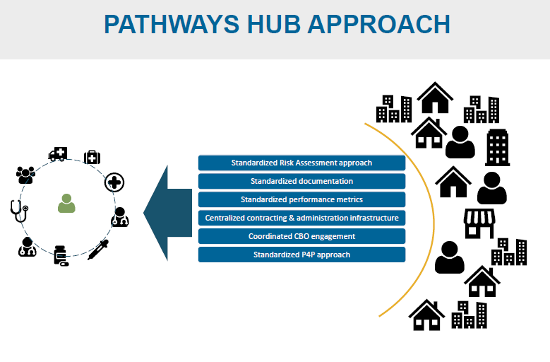
Figure 22: Pathways Community HUB Model
*Source: Health Management Associates, 2022.

Evaluation of the model’s impact has shown significantly lower neonatal admissions for participants with high-risk pregnancies. HUBs are active in New Mexico, Ohio, Oregon, Michigan, Minnesota, Texas, Washington, and Wisconsin, and in development in several other states.

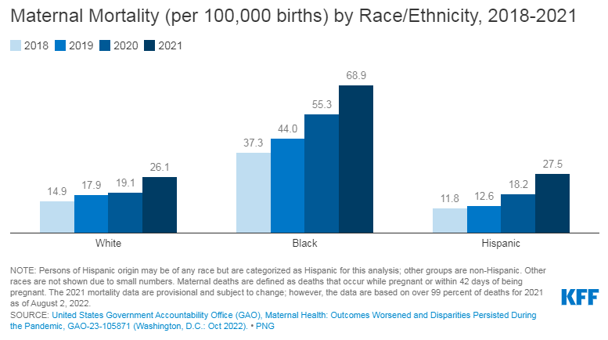
Figure 23: Worsening Maternal Outcomes and Disparities, 2018-2021
Underlying all these efforts, the COVID-19 pandemic and limitations of the response worsened maternal mortality and increased racial disparities in birth outcomes, as shown in Figure 6. Native Americans and Alaska Natives also experienced a disproportionate share of COVID-19 deaths and related declines in life expectancy, though data collection specific to maternal and infant outcomes has been inadequate.

Housing and Perinatal Outcomes
Housing instability has a wide range of negative effects on health and birth outcomes, and increasing housing security is also a strategy to support perinatal health. For example, women experiencing severe housing insecurity during pregnancy had 1.73 times higher risk of having low birthweight neonates and/or preterm birth and 1.64 times higher risk for Neonatal Intensive Care Unit admission than individuals who did not experience severe housing insecurity.

Public policy at the federal, state, and local levels needs to address housing affordability and availability; targeted efforts are also needed and can be addressed in part at the federal level but also at the state and local levels. For example, in recognition of this, the Federal MOMNIBUS Act includes housing as an area of focus. State Medicaid waivers also increasingly seek to address housing needs; federal matching funds can be drawn down for services to meet SDOH needs with CMS permission. Housing supply, particularly of affordable housing but also more broadly, is a major challenge in many areas with substantial political barriers to addressing root causes – broad-based, creative collaboration and political action are needed to begin to address it.

Birth Equity and Reproductive Justice – Shaping the Response to Maternal and Infant Mortality Disparities
At all levels, efforts to eliminate racial disparities in birth outcomes and make birth safer for birthing people increasingly recognize the importance of birth equity and the reproductive justice movement in shaping health system and broader responses. The National Birth Equity Collaborative, founded by Dr. Joia Crear-Perry, defines birth equity for all Black birthing people as: “The assurance of the conditions of optimal births for all people with a willingness to address racial and social inequities in a sustained effort.” The organization’s policy agenda for birth equity includes:

  - Reproductive health and autonomy are promoted and protected at the highest levels of government.
    - Recommendation: Create an Office of Reproductive Well-being in the White House dedicated to promoting reproductive health through a human rights and racial equity lens.
  - Health is a government priority and a recognized right.
    - Recommendation: Guarantee access to essential healthcare for everyone in the United States by recognizing the human right to health in U.S. law and requiring the government to ensure affordable, quality healthcare is available to all.
  - Individuals and institutions are held accountable for discrimination that leads to disparate health impacts.
    - Recommendation: Prohibit laws, policies, and practices that cause preventable inequalities in health outcomes, regardless of their intent, and ensure that standards for assessing discrimination in the healthcare system recognize disparate impacts and align with human rights standards.
  - No maternal death goes unnoticed or uncounted.
    - Recommendation: Require and support all states and U.S. territories to collect and disseminate maternal mortality and morbidity data, disaggregated by race and ethnicity.
  - Government involvement in reproductive health may not intrude on reproductive freedom, agency, and autonomy.
    - Recommendation: Remove restrictions on reproductive health care that limit reproductive decision-making, such as the Hyde Amendment and the global and U.S. “gag rules,” and ensure that all state and federal funding and regulations related to reproductive health are free from coercive measures.

Reproductive Justice
The Reproductive Justice framework and movement has set a broader context for efforts to eliminate racial disparities in birth outcomes that implicates a broader set of solutions focused on addressing historical and current inequities. As described by the National Birth Equity Collaborative:
“Coined by the SisterSong Women of Color Reproductive Justice Collective in 1994, Reproductive Justice (RJ) is the human right to maintain personal bodily autonomy, have children, not have children, and to parent children in safe and sustainable communities. RJ is the complete physical, mental, political, environmental, social, and economic well-being of women and girls based on the full protection of their human rights.
Factors such as education, income, geographic location, immigration status, and potential language barriers, and equitable access to healthcare are common barriers to achieving reproductive justice.
The RJ Framework encompasses both reproductive health and reproductive rights, while also using an intersectional analysis to emphasize and address the social, political, and economic inequities that affect women's reproductive health and their ability to control their reproductive lives. It examines how the ability of any woman to determine their own reproductive destiny is directly linked to the conditions of their communities and how they are impacted by reproductive and systematic oppression.”

Federal, state, and local efforts have increasingly sought to address these broader drivers of birth outcomes, without which previous efforts have had limited impact.

Measuring Obstetric Racism
In the clinical arena, additional tools are also emerging to identify and address racism and its impact on care and outcomes. These include the PREM-OB Scale™, which “provides a numerical score of how well hospital clinicians and staff promote and/or violate high(er) quality of care in safety, autonomy, communication, racism, empathy, and dignity in service provision as defined for, by, and with Black mothers and birthing people and Black women scholars. The PREM-OB Scale™ allows for Black mothers and birthing people to share information about their unique patient experiences in hospital settings during labor, birth, and postpartum. The information gained from the PREM-OB Scale™ will help hospitals, health plans, scientists, funders, and the public better understand how obstetric racism and other forms of neglect and mistreatment affect the ways that hospitals provide care, services, and support to Black mothers and birthing people during labor, birth, and postpartum.”

Medicaid Policy and Program Approaches
Postpartum Medicaid expansion has gained extensive state support and uptake in recent years, with 29 states (including Washington, D.C) and Delaware enacting 1-year postpartum Medicaid coverage expansions. The American Rescue Plan Act of 2021 provided states with a new option to extend Medicaid postpartum coverage to 12 months via a state plan amendment (SPA), starting on April 1, 2022 and continuing for five years, an opportunity that accelerated state expansions. Seven additional states are planning to implement expansions, three have pending legislation to expand through a SPA or Medicaid waiver, and two others have more limited expansions, as of February 23, 2023. In addition, North Carolina announced an agreement to take up the Affordable Care Act’s Medicaid expansion for people under 138% of the Federal Poverty Level, which once implemented would leave just 10 states that have not yet expanded (Delaware implemented the expansion in 2014).

In addition, states are increasingly considering, planning, or implementing coverage of doula services through Medicaid and taking related steps to build doula workforce capacity, particularly to better serve women of color. Eight states and Washington, D.C. are providing coverage, six states are at various stages of implementation, and 15 others have taken some type of related action to advance Medicaid coverage for doula services; Delaware is in the process of implementing this benefit.

Some states are also implementing or expanding Medicaid coverage for other services focused on improving maternal and infant health, including:
- Home visiting
- Postpartum services provided by lactation counselors and consultants, public health nurses, and medical caseworkers
- Targeted case management and other programs to meet needs of pregnant and postpartum individuals with substance use disorders
- Using new payment, delivery, and performance measurement approaches.
- Five states (Illinois, Michigan, Minnesota, Nevada, and Texas) reported including Performance Improvement Projects (PIPS) for their Medicaid services that focused specifically on reducing disparities related to maternal and child health in Fiscal Year 2022.

Other State and Local Efforts
Several states have developed plans and initiatives to address disparities in maternal and infant outcomes, including:
- New Jersey’s Nurture NJ Strategic Plan to identify challenges, action areas, and recommendation to achieve equity for all women with a focus on dismantling structural racism and addressing social determinants of health.
- California is implementing legislatively required implicit bias training for all perinatal health workers, as well as elements of the California MOMNIBUS legislation, which directs the state to invest in areas including improved data analysis, streamlining administrative procedures for pregnant people, and expanding the midwifery workforce.

Guaranteed Basic Income to Support Birth Outcomes
As part of broader attention to—and pilot projects exploring—the impacts of guaranteed basic income, its effects on birth outcomes and the health of pregnant and parenting people have been a focus of multiple programs, including Delaware’s guaranteed basic income pilot.

Abundant Birth Project
The Abundant Birth Project is a pilot program launched in 2021 to provide pregnant Black and Pacific Islander women in San Francisco with a monthly income supplement for the duration of their pregnancy and two months postpartum as an economic and reproductive health intervention, with the primary goals of reducing premature births and improving economic outcomes. It is being implemented by Expecting Justice, “a Black-led collaborative, mobilizing leaders from across San Francisco to take action to improve maternal and infant health in Black and Pacific Islander Communities.” Participants receive a monthly income supplement of approximately $1,000 per month for the duration of their pregnancy and first two months postpartum. The initiative aims to expand to two years postpartum. The effort is rooted in racial justice and recognizes the influence of wealth and income disparities on Black and Pacific Islander women’s birth outcomes. The project is a fully funded public-private partnership developed using the collaborative change model, which directly involves all impacted and interested parties in decision-making. UC Berkeley, UCSF and community researchers from Black and Pacific Islander communities are evaluating the program and will be releasing results. The program has given $1,000 per month to nearly 150 Black pregnant and postpartum people in San Francisco, and an expansion was announced in December 2022. The program will receive $6.5 million in city and state funding and will expand its services to Alameda, Contra Costa, Los Angeles, and Riverside counties.

Stockton UBI
While Stockton’s Universal Basic Income (UBI) program was not focused on birth outcomes, the results suggested positive impact on pregnant and parenting women’s health. The program offered $500 a month to 125 randomly selected individuals living in neighborhoods with average incomes lower than the city median of $46,000 a year. Participants spent the money as they desired and were not obligated to complete any drug tests, interviews, means or asset tests, or work requirements. The results included reduced income volatility, increased employment, and improved self-reported health – including reduced depression and anxiety and increased well-being. Recipients were less anxious and depressed, both over time and compared to the control group. The findings included that women who typically prioritized the needs of others over their own well-being were able to focus on their health and subsidize gaps in family health care. The Stockton UBI pilot has ended, but the Mayors For a Guaranteed Income group and other policymakers nationwide continue to expand the approach.

State/local efforts & strategies
Amid the challenges of the pandemic and a backdrop of changing federal policies and administrations, state and local efforts to support better birth outcomes and eliminate racial disparities have continued to grow and evolve, including by increasingly targeting “upstream” drivers of health including socioeconomic conditions and, in some cases, racism.

Latoya Hill, Samantha Artiga, and Usha Ranji, “Racial Disparities in Maternal and Infant Health: Current Status and Efforts to Address Them,” KFF, November 1, 2022. See https://www.kff.org/racial-equity-and-health-policy/issue-brief/racial-disparities-in-maternal-and-infant-health-current-status-and-efforts-to-address-them/
Daniel Blake and Julie Coveney. California State University Northridge. Family Source Network: Impact Study Results Year 6
Latoya Hill, Samantha Artiga, and Usha Ranji, “Racial Disparities in Maternal and Infant Health: Current Status and Efforts to Address Them,” KFF, November 1, 2022. See https://www.kff.org/racial-equity-and-health-policy/issue-brief/racial-disparities-in-maternal-and-infant-health-current-status-and-efforts-to-address-them/
Hill, Artiga, and Ranji, 2022.
Within Delaware, the highest rate of infant mortality was in the City of Wilmington and the overall lowest rate was in Sussex County. Other critical disparities include increased postnatal neonatal mortality rate for Black babies, increasing infant mortality rate for Black babies in Kent County, and increasing infant mortality rate for Hispanic babies in Wilmington.
DRH_Hussaini_DataBrief_Reproductive_Health_2012-2021.pdf (s3.us-east-1.amazonaws.com)
Healthy Women Healthy Babies Mini-Grants - Delaware Thrives (dethrives.com)
In all cases, grantees made it clear to potential participants that participation in services is not linked with participation in the evaluation. Participants were made aware that they could still receive all services, even if they chose not to participate in the evaluation.
Copyright ©2023 The Dibble Institute ®
The framework emerged out of the design and evaluation of the Freshplace food pantry located in Hartford, Connecticut. Martin K, Wu R, Wolff M, Colantonio A, Grady J. A novel food pantry program: food security, self-sufficiency, and diet-quality outcomes. Am J Prev Med. 2013;45 (5):569–575. doi:10.1016/j.amepre.2013.06.012. Martin K, Colantonio A, Boyle K, Picho K. Self-efficacy is associated with increased food security in novel food pantry program. Soc Sci Med Pop Health. 2016;2:62–67.
Daniel Blake and Julie Coveney. California State University Northridge. Family Source Network: Impact Study Results Year 6
Delaware Health Statistics Center. Delaware Vital Statistics Annual Report, 2020. Delaware Department of Health and Social Services, Division of Public Health: 2023. https://dhss.delaware.gov/dhss/dph/hp/files////infant_mortality20.pdf
Latoya Hill, Samantha Artiga, and Usha Ranji, “Racial Disparities in Maternal and Infant Health: Current Status and Efforts to Address Them,” KFF, November 1, 2022. See https://www.kff.org/racial-equity-and-health-policy/issue-brief/racial-disparities-in-maternal-and-infant-health-current-status-and-efforts-to-address-them/
Hill, Artiga, and Ranji, 2022.
Healthy Women Healthy Babies Mini-Grants - Delaware Thrives (dethrives.com)
https://www.kff.org/racial-equity-and-health-policy/issue-brief/racial-disparities-in-maternal-and-infant-health-current-status-and-efforts-to-address-them/#:~:text=Research%20has%20documented%20that%20social,of%20mortality%20among%20Black%20infants
See the Prenatal-to-3 Policy Impact Center’s 2022 Prenatal-to-3 State Policy Roadmap at https://pn3policy.org/pn-3-state-policy-roadmap-2022/.
See https://www.hhs.gov/about/news/2021/09/17/hhs-announces-350-million-to-strengthen-maternal-child-health-across-the-nation.html
See https://www.nichq.org/project/collaborative-improvement-and-innovation-network-reduce-infant-mortality-infant-mortality
The evidence for the effectiveness of 17 OH progesterone has recently come into question, with an expert panel convened by the Food and Drug Administration concluding in October 2022 that it is not effective in preventing preterm birth and recommending the FDA withdraw approval of the drug. See: https://khn.org/news/call-for-fda-to-withdraw-preterm-birth-drug-makena-divides-doctors-and-insurers/
See https://www.healthybabiesbaltimore.com/collective-impact-strategy for further detail and updates.
See https://www.ahrq.gov/innovations/hub/index.html
Lucas, B., Detty, A. “Improved Birth Outcomes Through Health Plan and Community HUB Partnership,” Buckeye Health Plan, December 2018.
Goldman N, Andrasfay T. Life expectancy loss among Native Americans during the COVID-19 pandemic. Demogr Res. 2022 Jul-Dec;47:233-246. doi: 10.4054/demres.2022.47.9. Epub 2022 Jul 27. PMID: 36506651; PMCID: PMC9733701.
Julia D. DiTosto, Kai Holder, Elizabeth Soyemi, Molly Beestrum, Lynn M. Yee, Housing instability and adverse perinatal outcomes: a systematic review, American Journal of Obstetrics & Gynecology MFM, Volume 3, Issue 6, 2021, 100477, ISSN 2589-9333, https://doi.org/10.1016/j.ajogmf.2021.100477.
See https://www.congress.gov/bill/118th-congress/house-bill/3305/text.
See examples at https://healthcare.rti.org/sites/default/files/2023-03/Table_1_Section%20111_347650_v2.pdf.
See https://birthequity.org/
National Birth Equity Collaborative, June 16, 2020 https://birthequity.org/wp-content/uploads/2021/11/Birth-Equity-Policy-Agenda.pdf
National Birth Equity Collaborative, How the Black Maternal Health Momnibus Act Advances Reproductive Justice: https://birthequity.org/wp-content/uploads/2021/11/BMHW-RJMomnibus-Full.docx.pdf
See https://sacredbirth.ucsf.edu/hospitals-health-centers-and-health-plans
KFF Medicaid Postpartum Coverage Extension Tracker, updated Feb 24, 2023. https://www.kff.org/medicaid/issue-brief/medicaid-postpartum-coverage-extension-tracker/
Rose Hoban “NC House and Senate Republicans reach milestone Medicaid expansion deal, but Democratic governor questions the timeline,” North Carolina Health News, March 3, 2023. https://www.northcarolinahealthnews.org/2023/03/03/nc-house-and-senate-republicans-reach-milestone-medicaid-expansion-deal-but-democratic-governor-questions-the-timeline/ Also see KFF “Status of State Action on the Medicaid Expansion Decision,” updated February 16, 2023. https://www.kff.org/medicaid/issue-brief/status-of-state-medicaid-expansion-decisions-interactive-map/
https://www.kff.org/racial-equity-and-health-policy/issue-brief/racial-disparities-in-maternal-and-infant-health-current-status-and-efforts-to-address-them
https://www.kff.org/racial-equity-and-health-policy/issue-brief/racial-disparities-in-maternal-and-infant-health-current-status-and-efforts-to-address-them
See https://pretermbirthca.ucsf.edu/abundant-birth-project
See https://www.expectingjustice.org/
See https://www.stocktondemonstration.org/health-and-wellbeing; https://www.mayorsforagi.org

